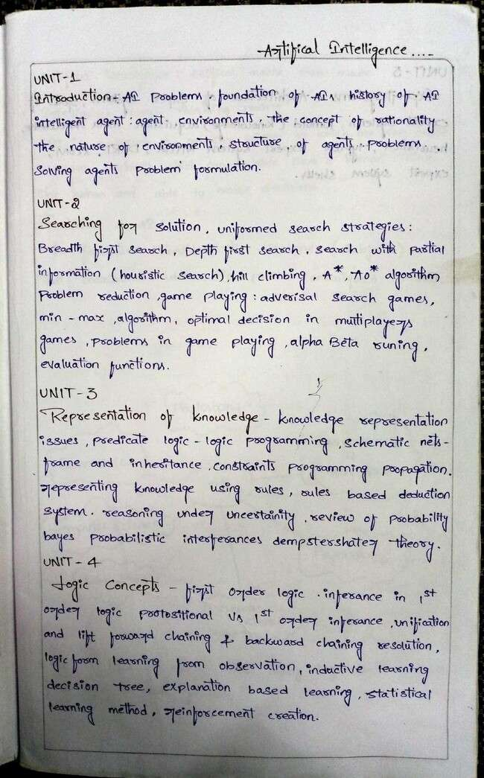

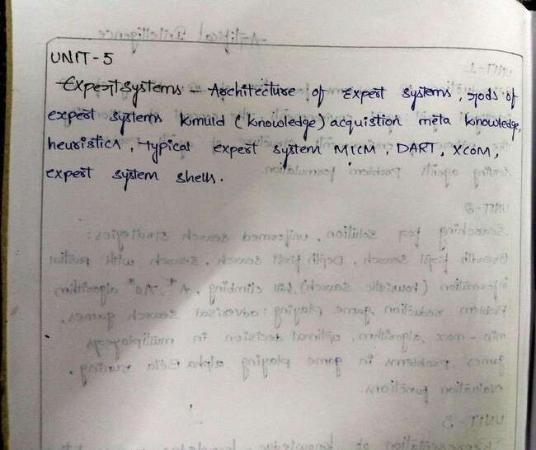

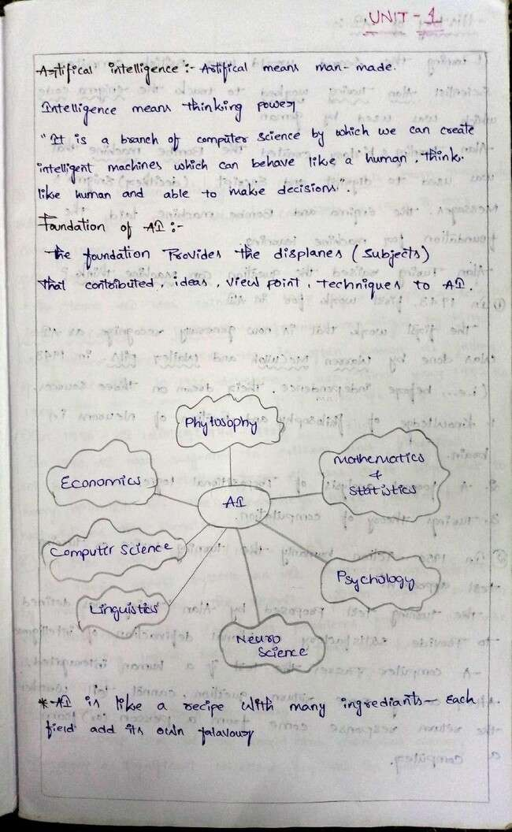

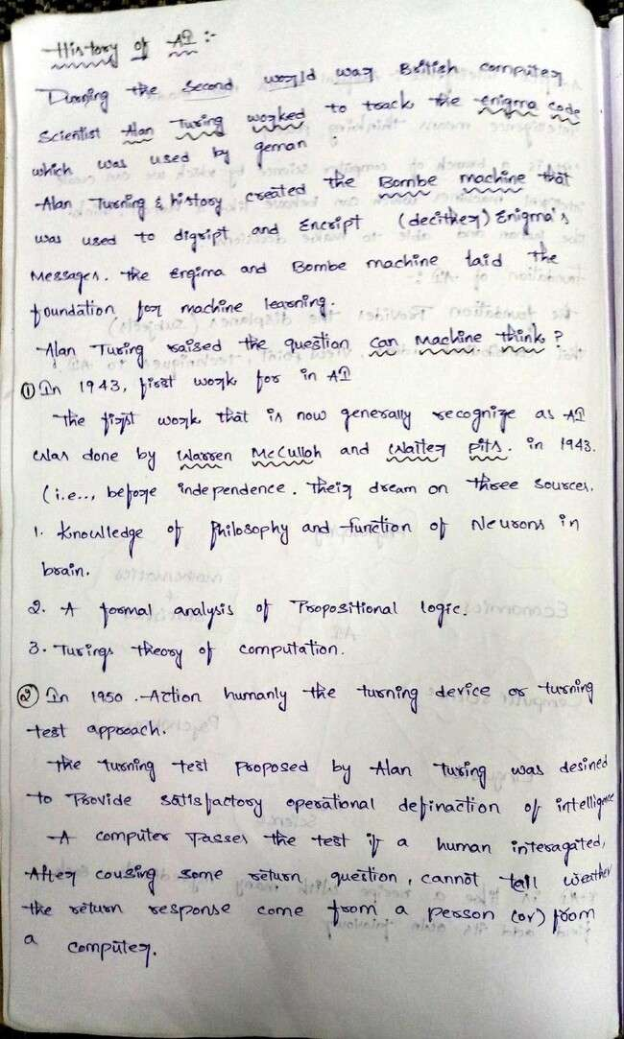

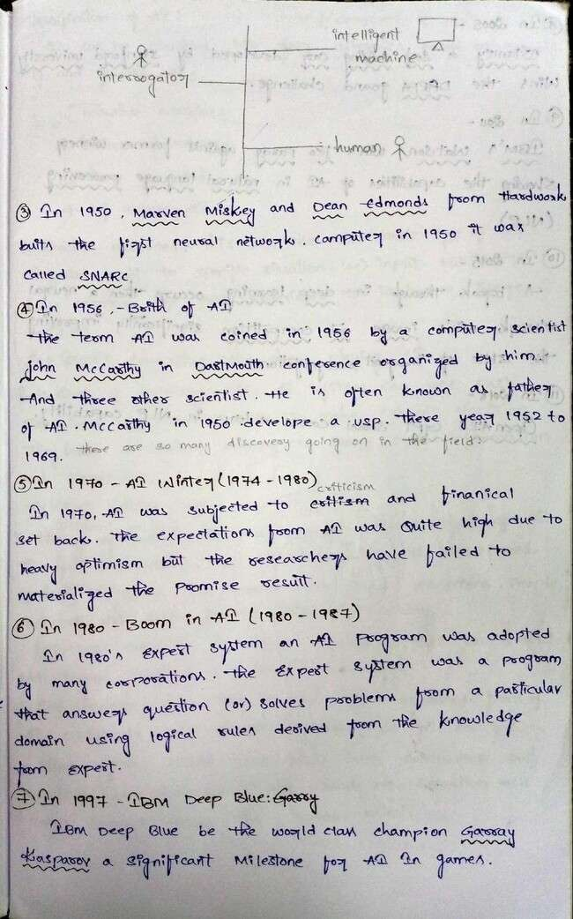

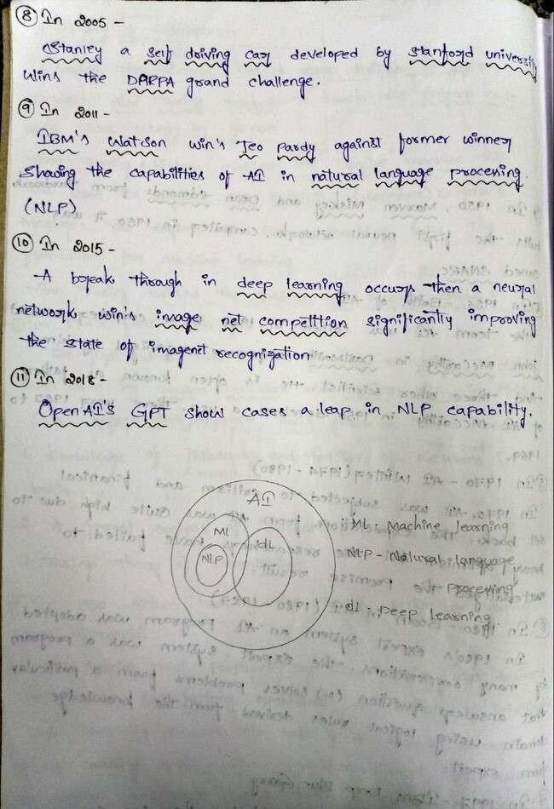

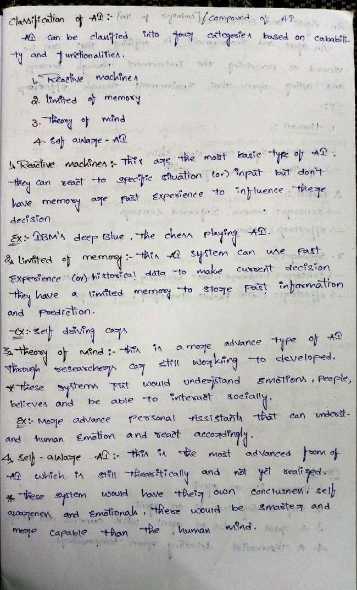

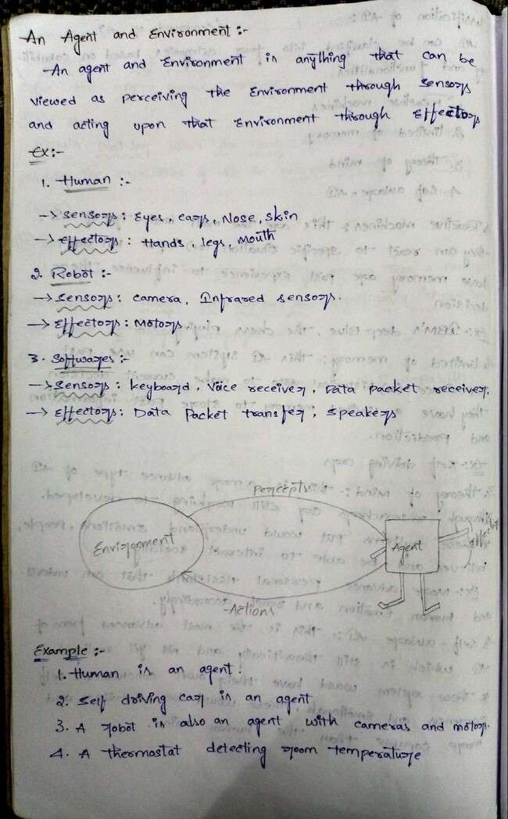

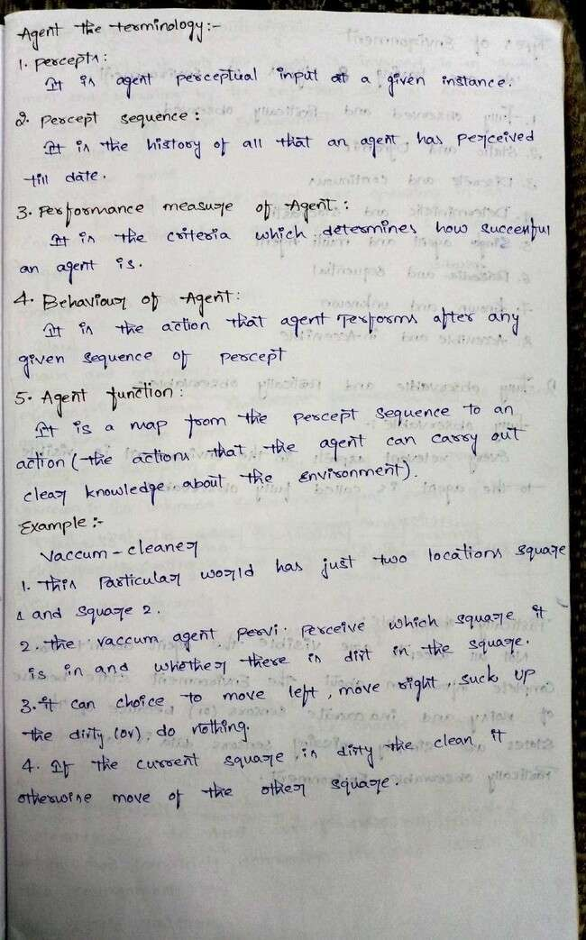

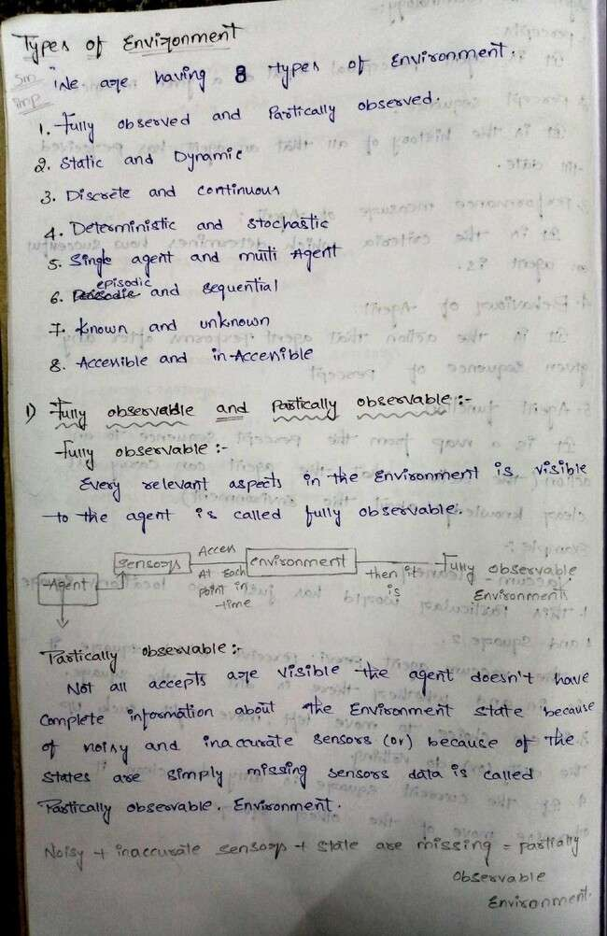

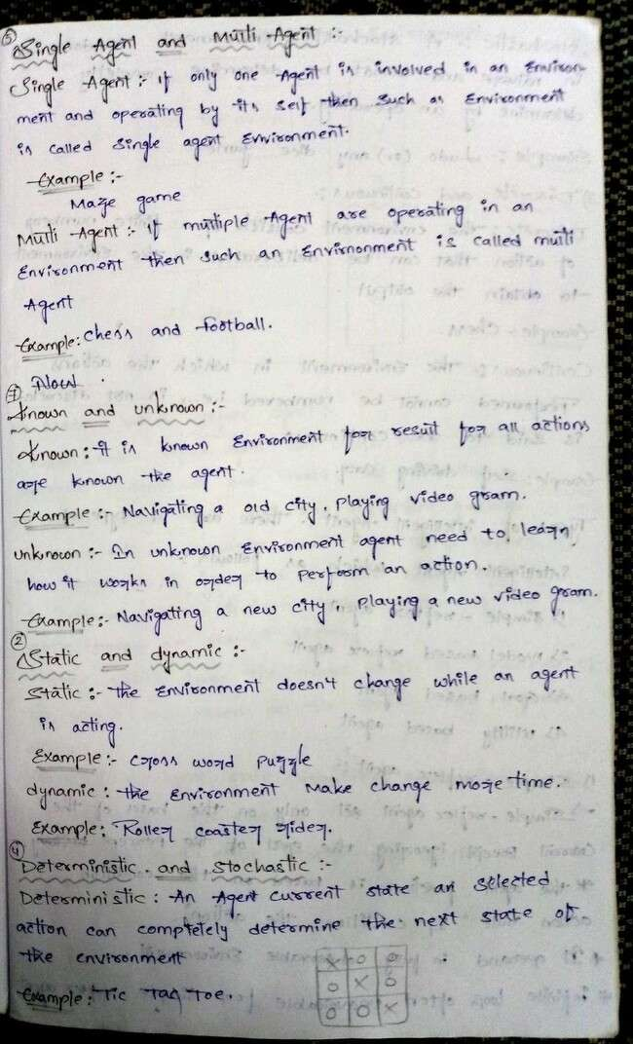

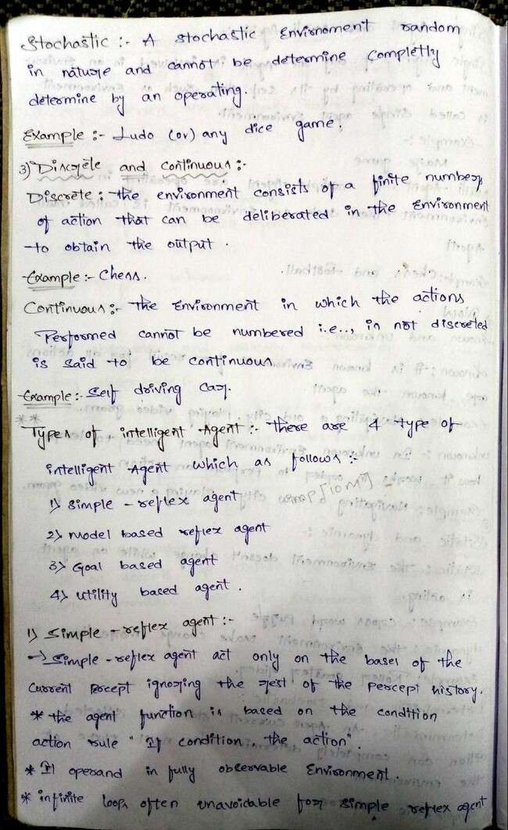

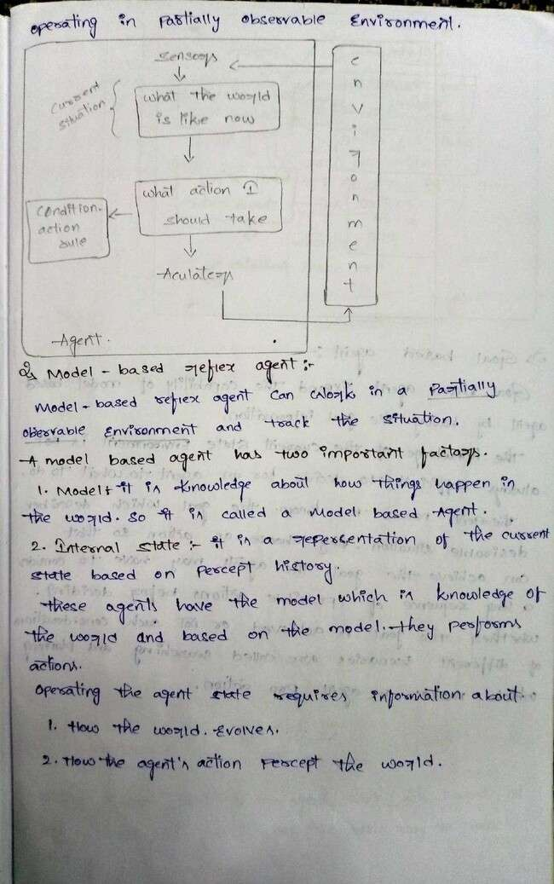

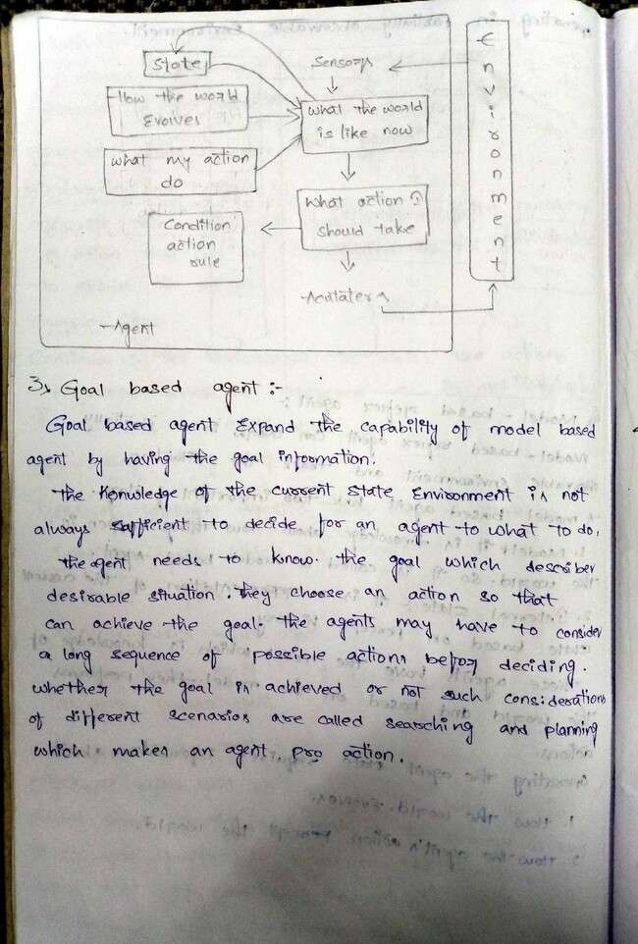

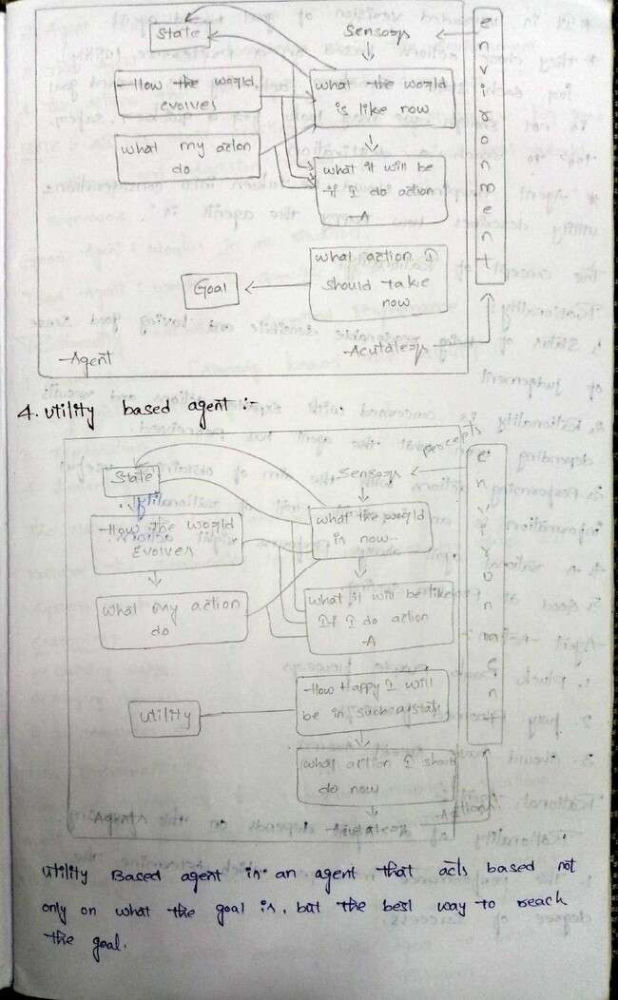

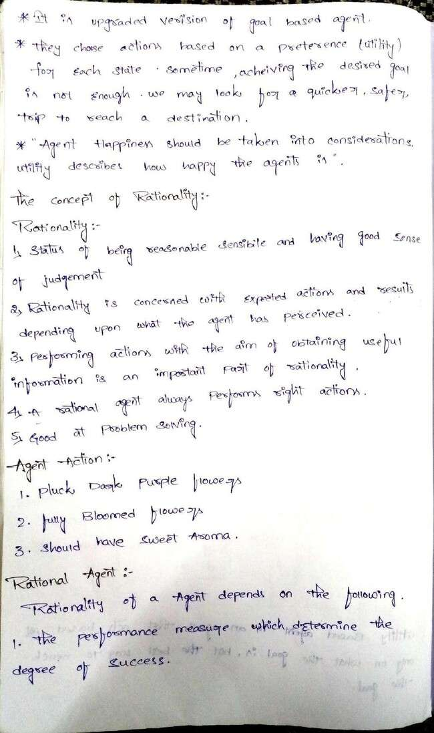

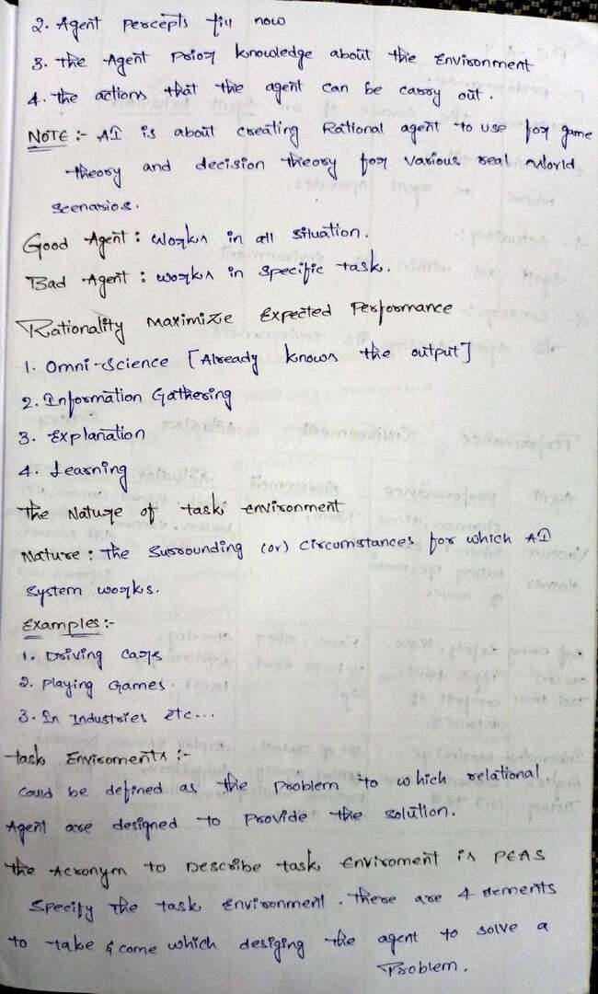

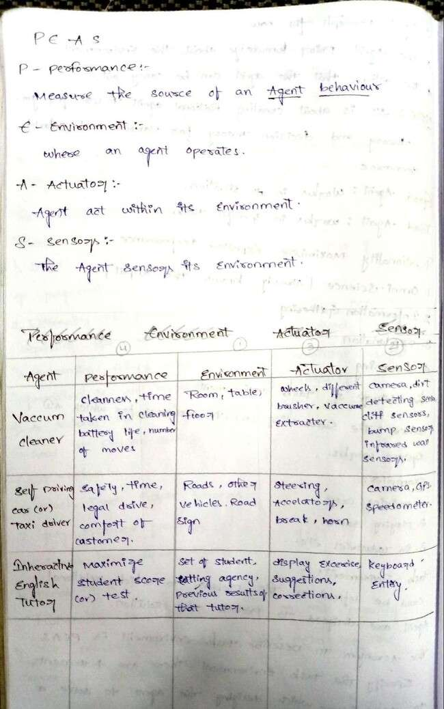

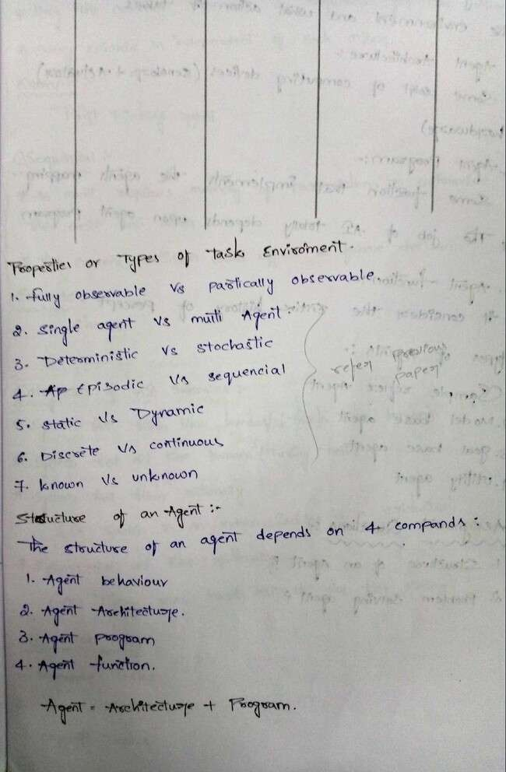

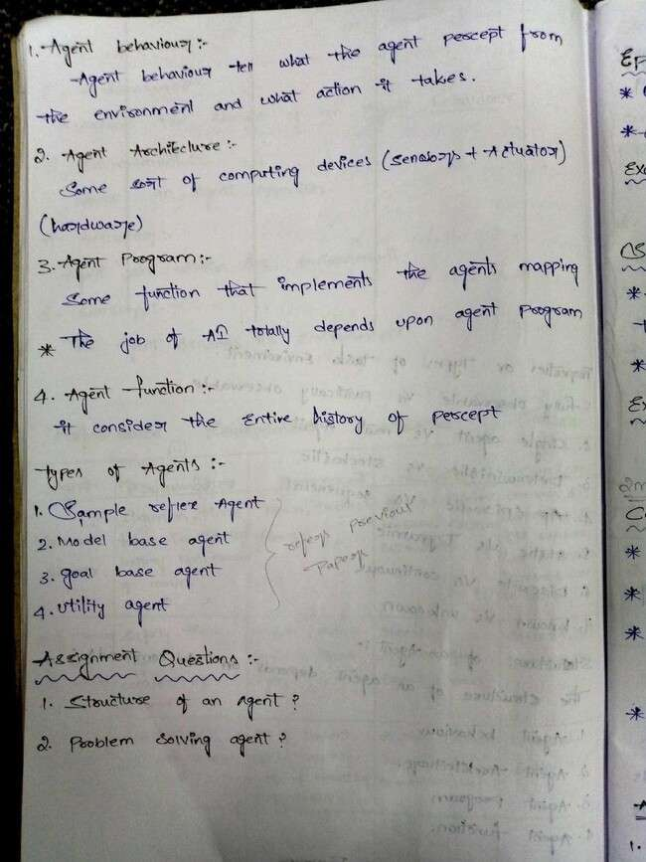

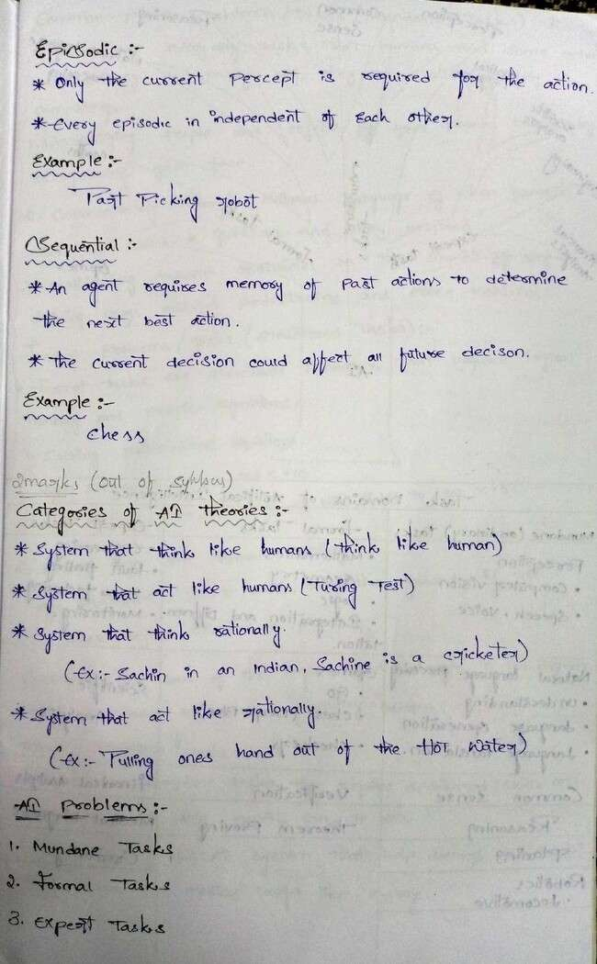

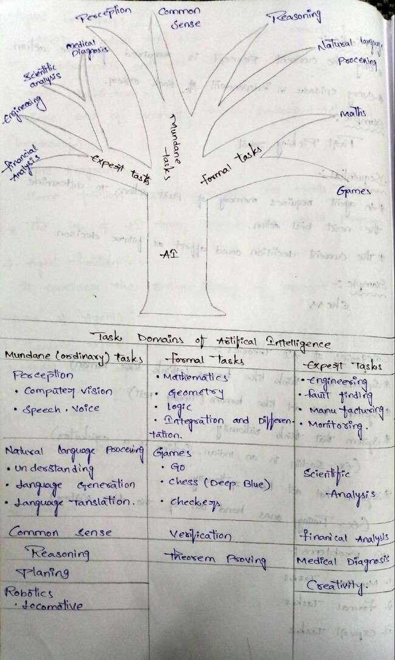

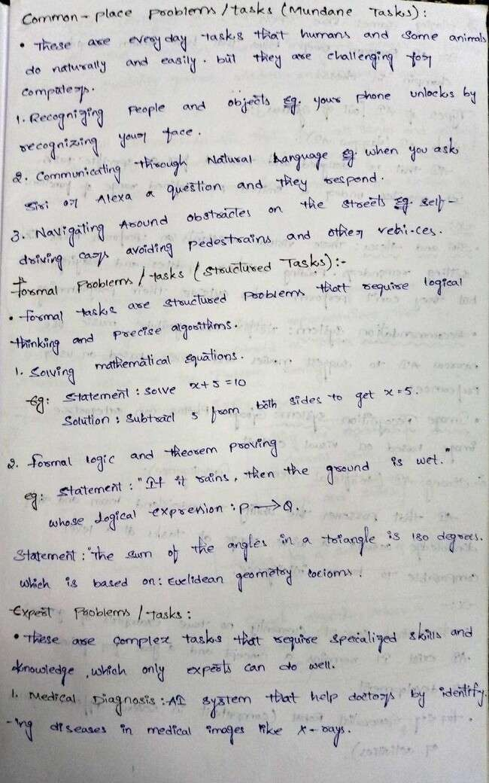

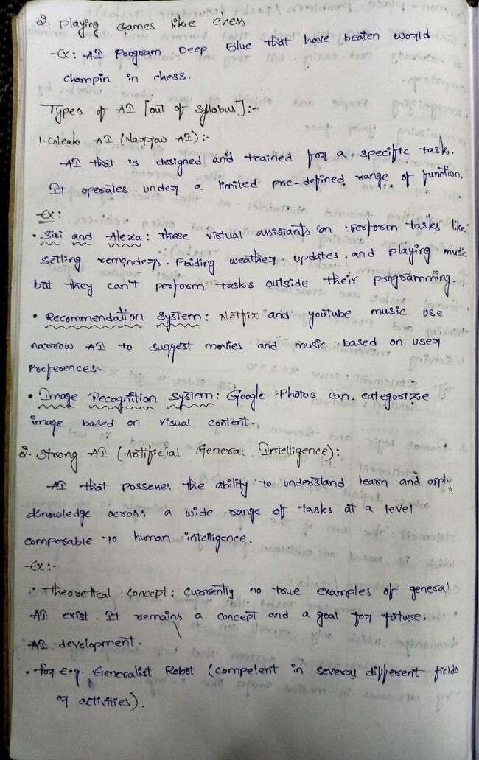

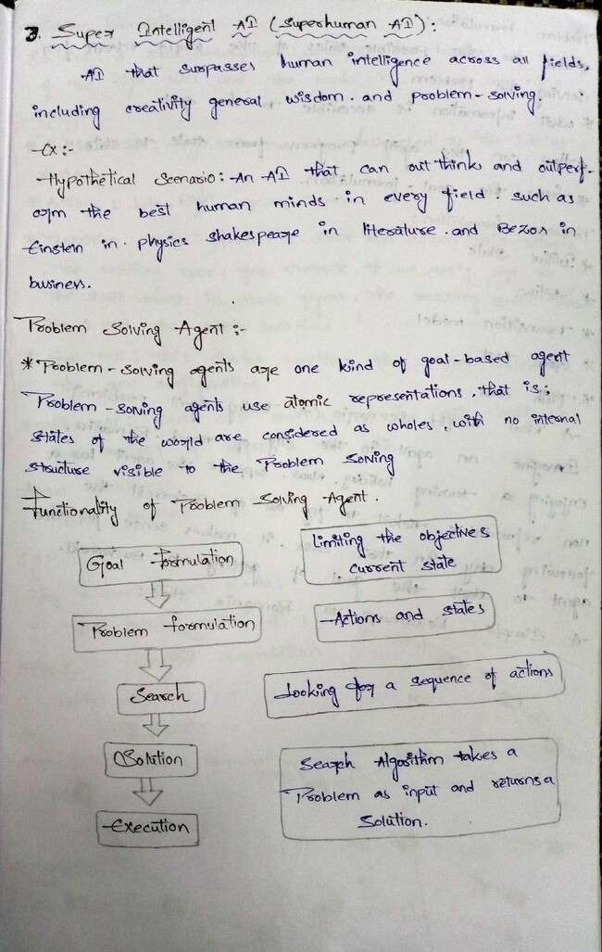

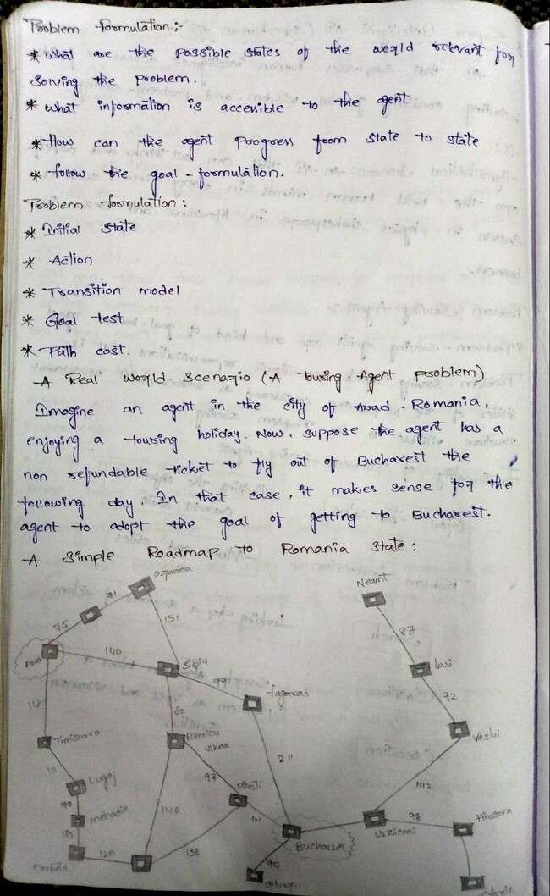

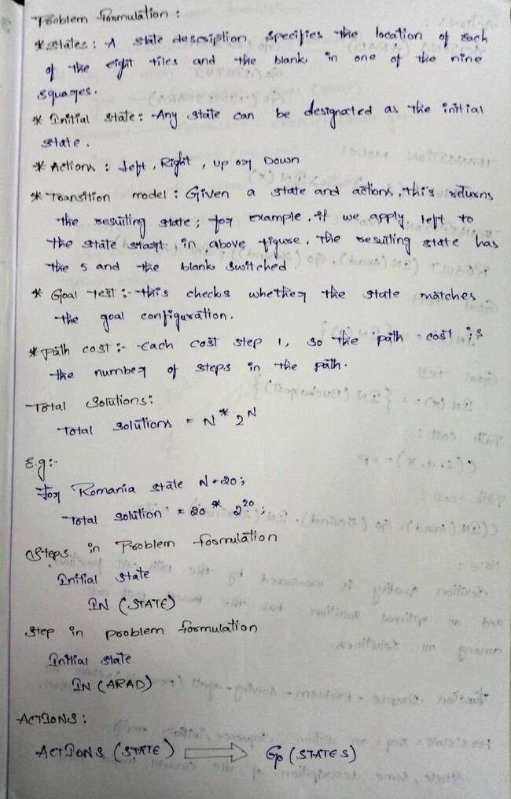

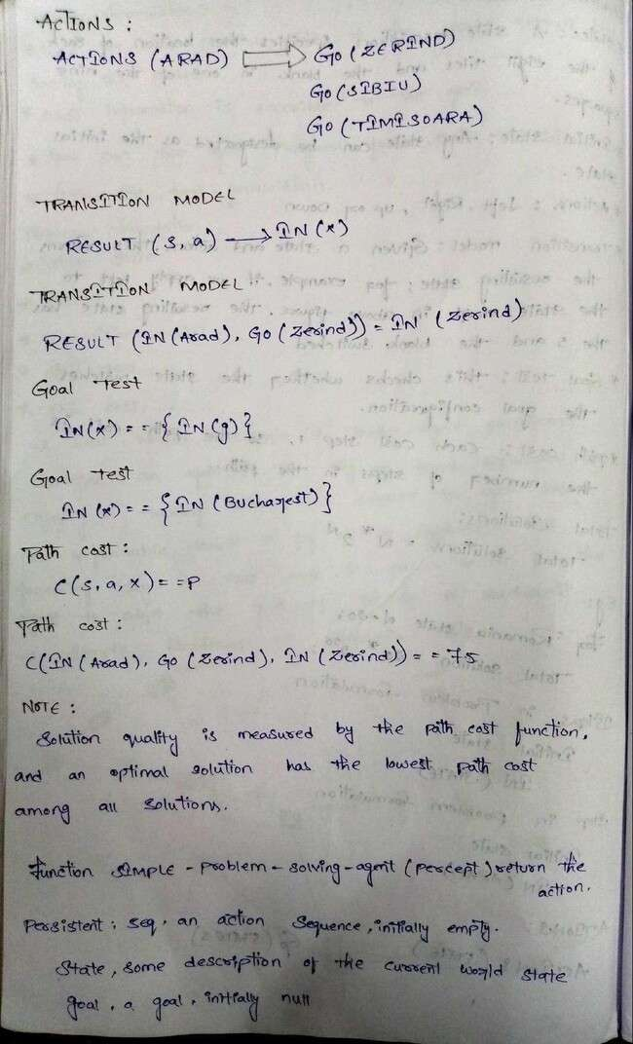

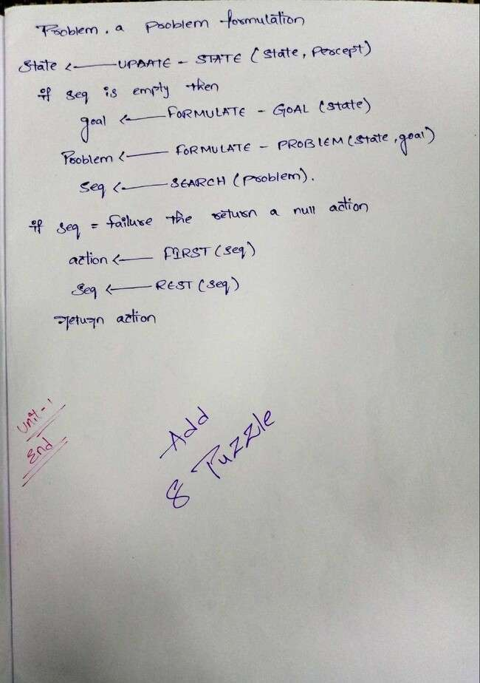

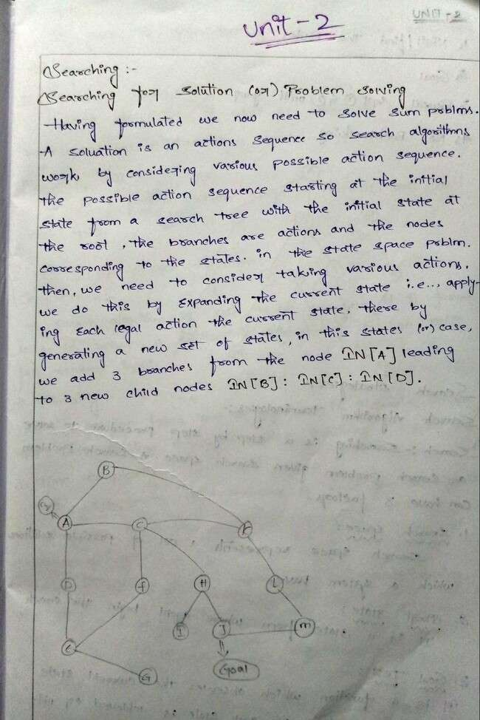

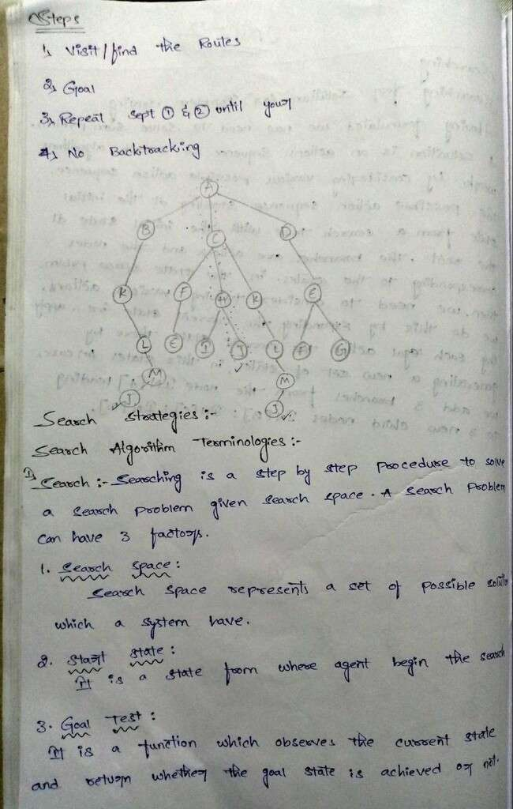

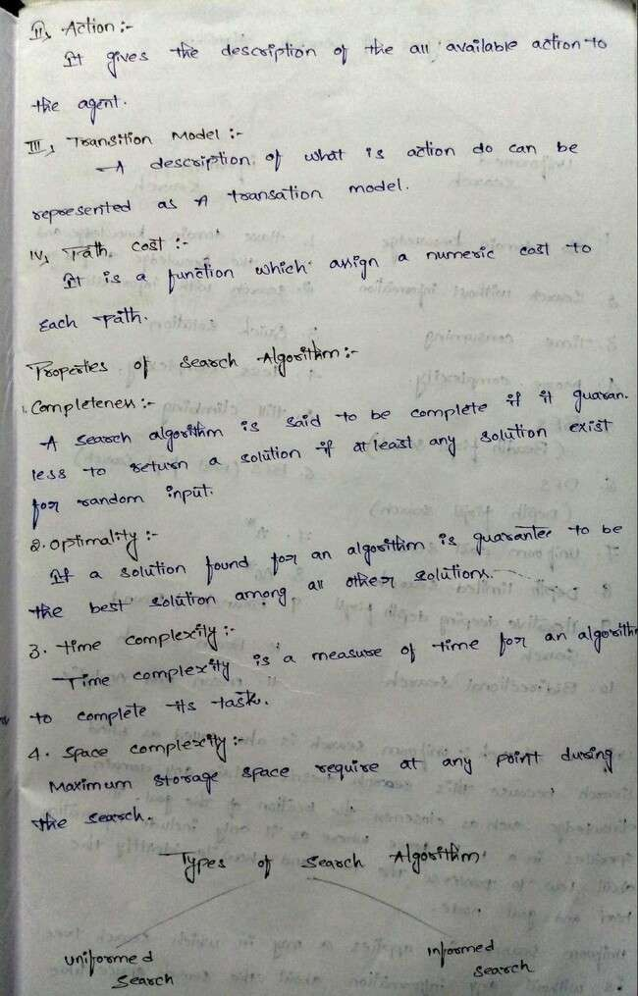

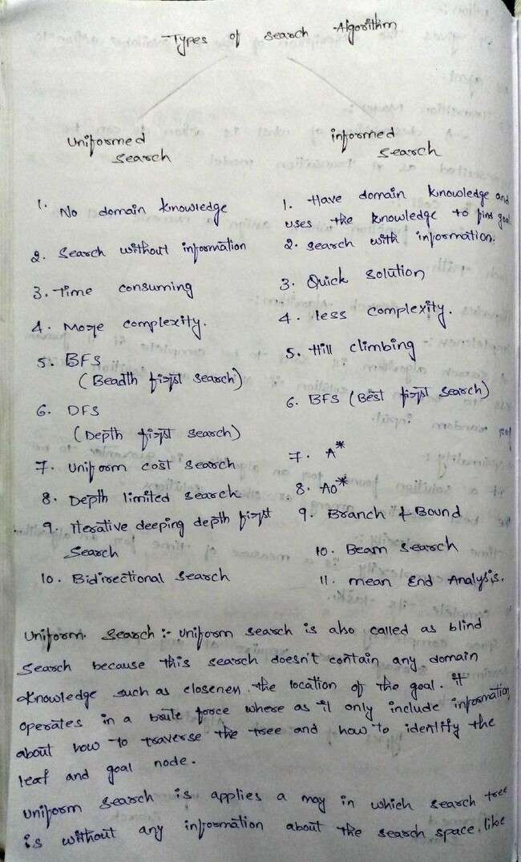

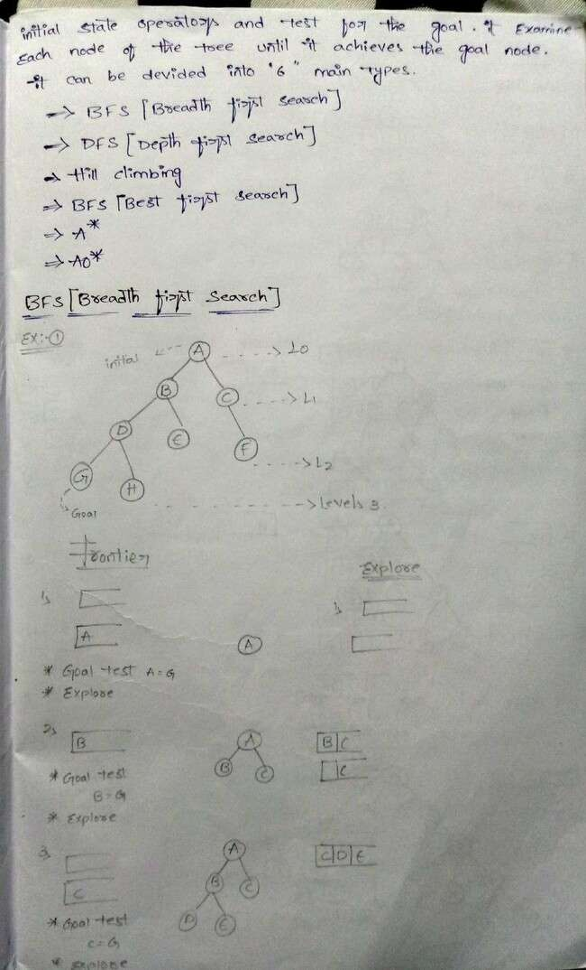

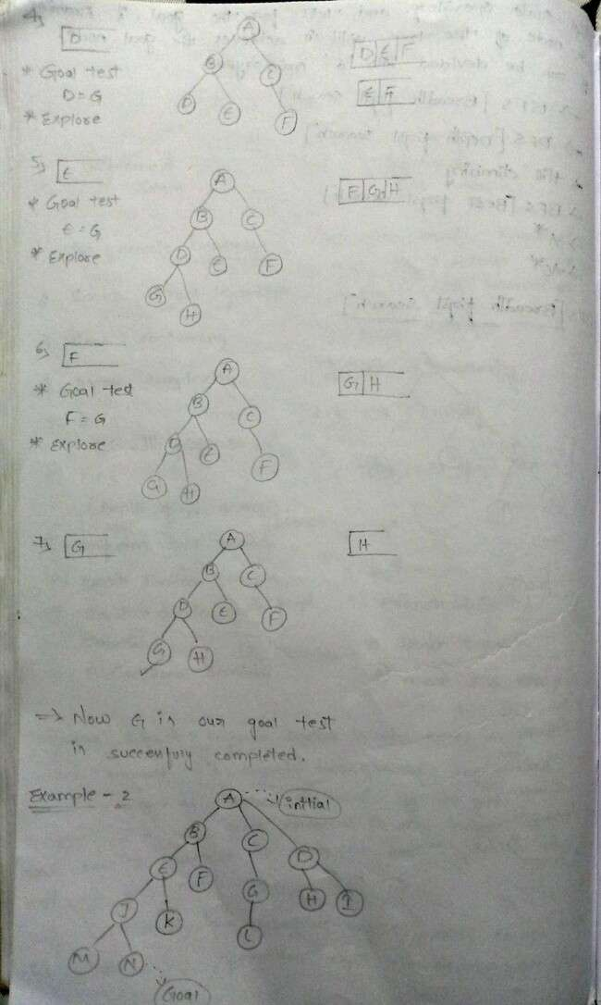

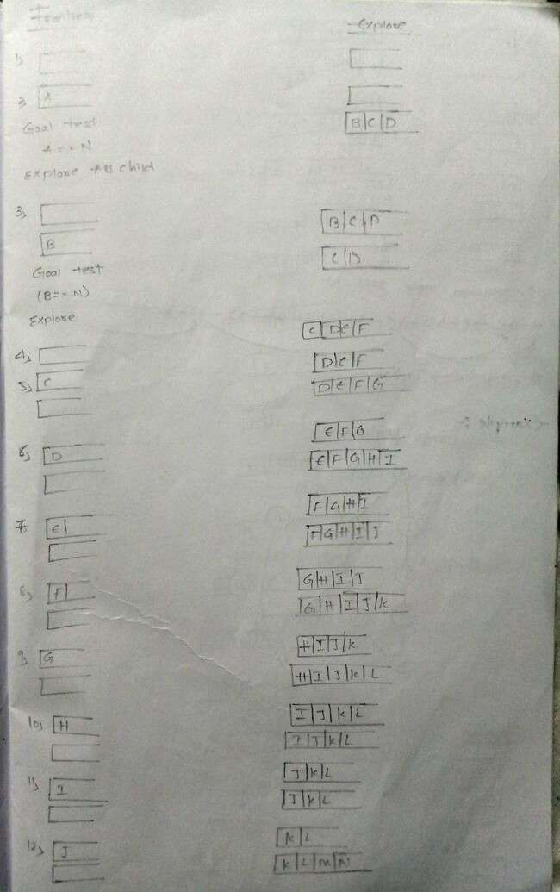

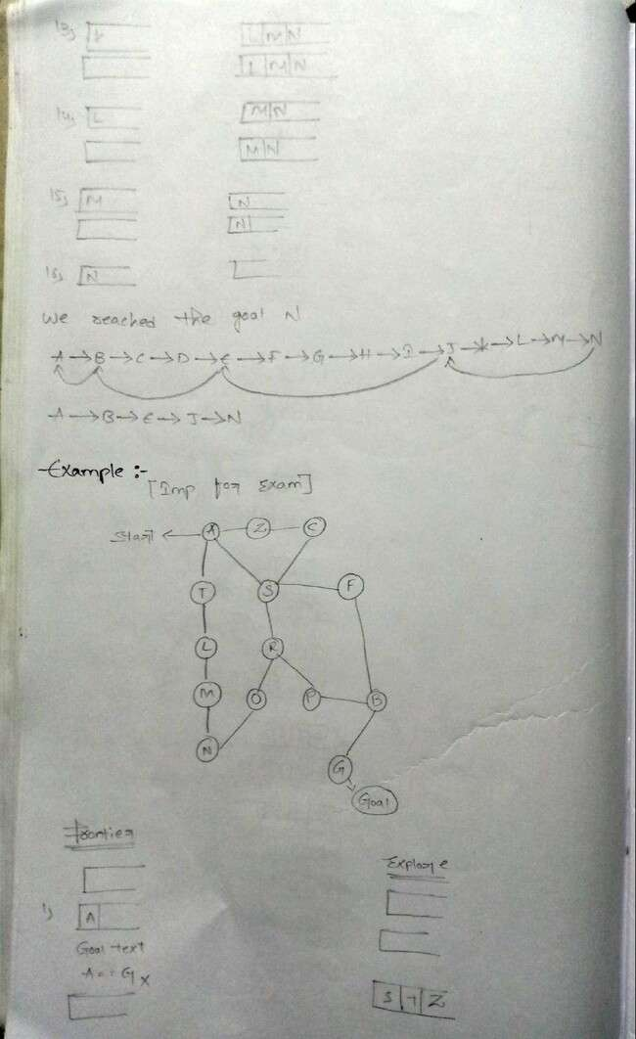

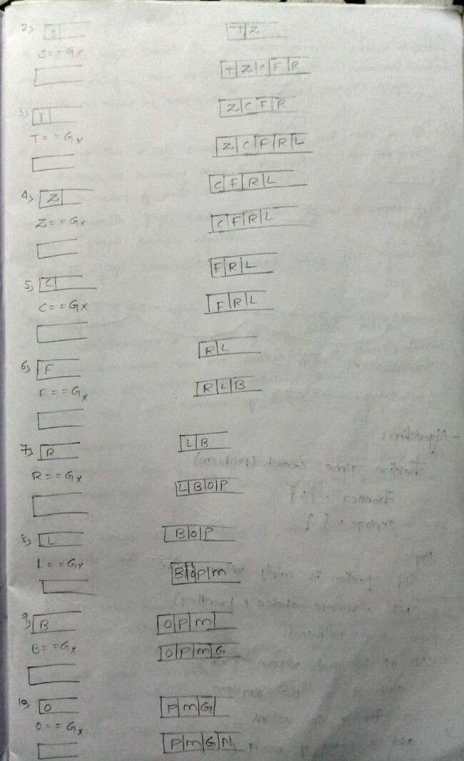

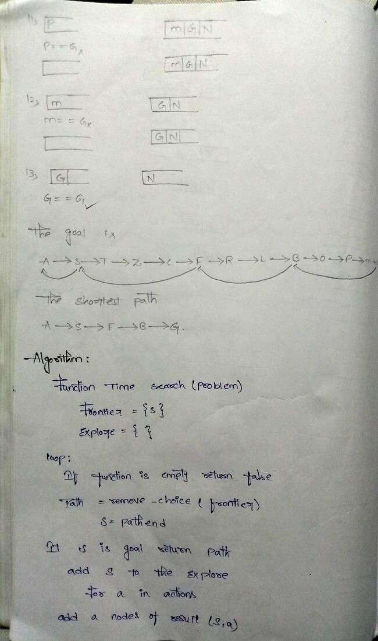

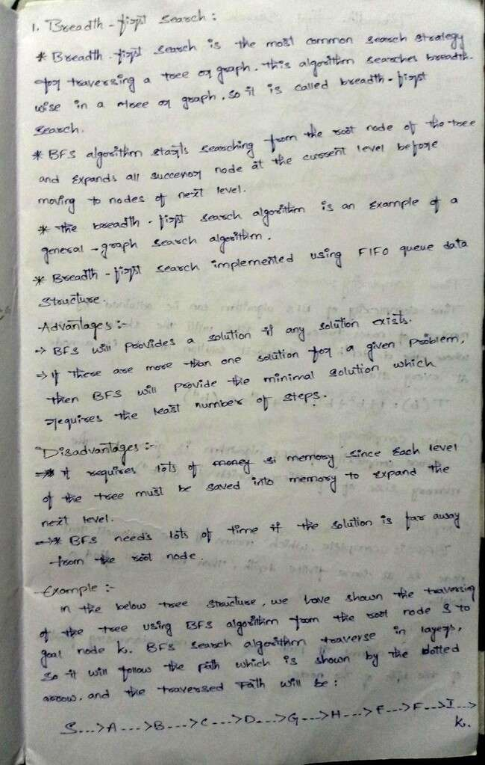

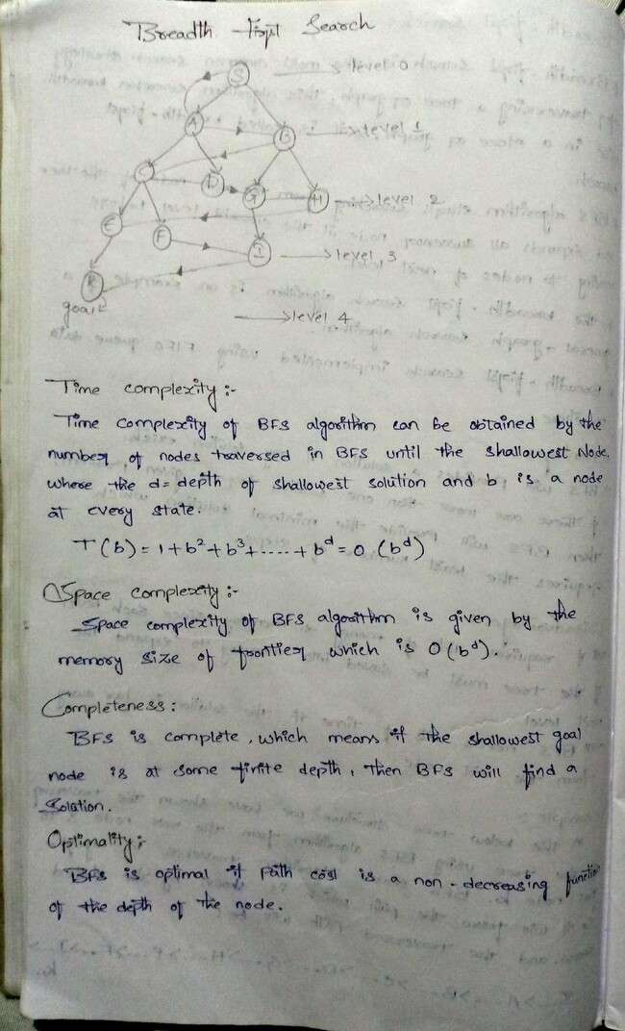

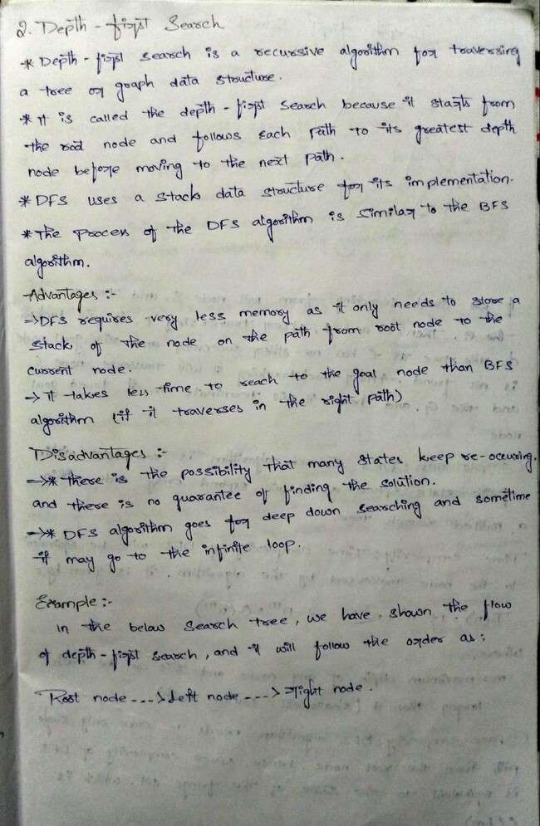

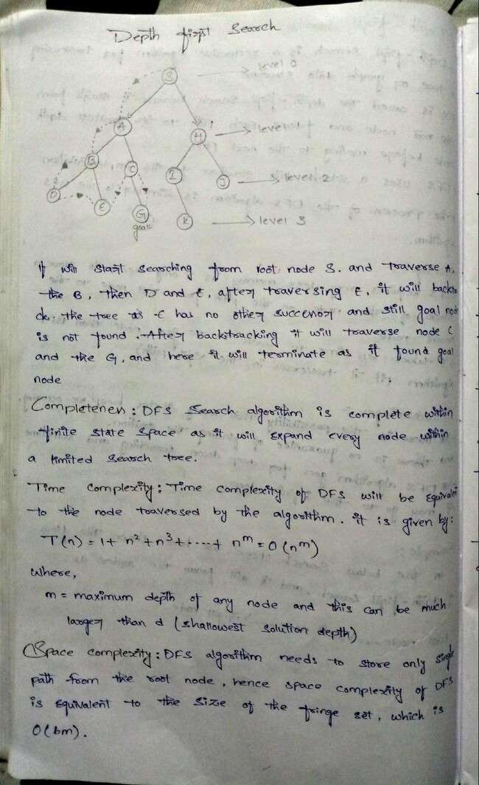

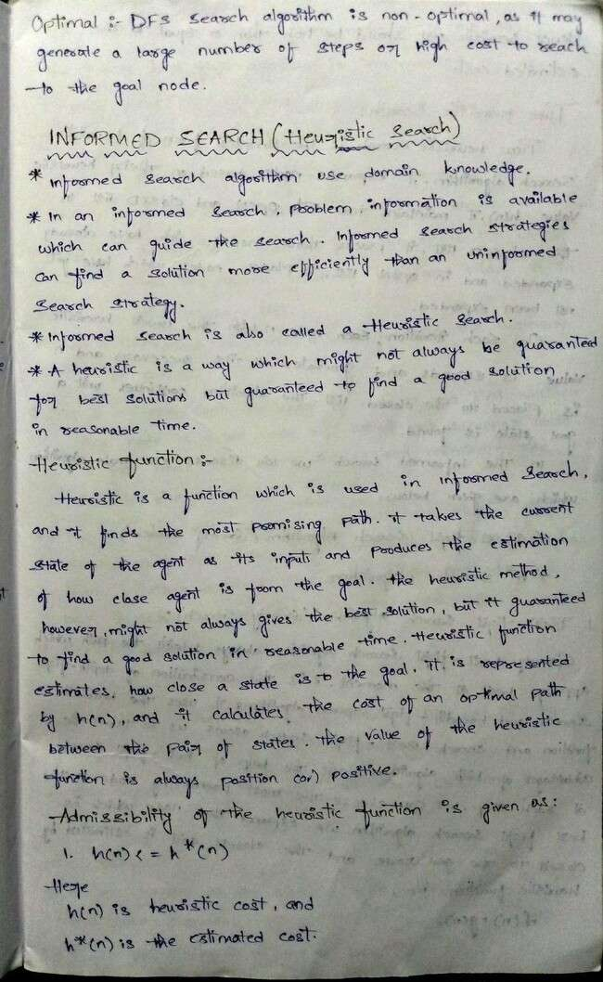

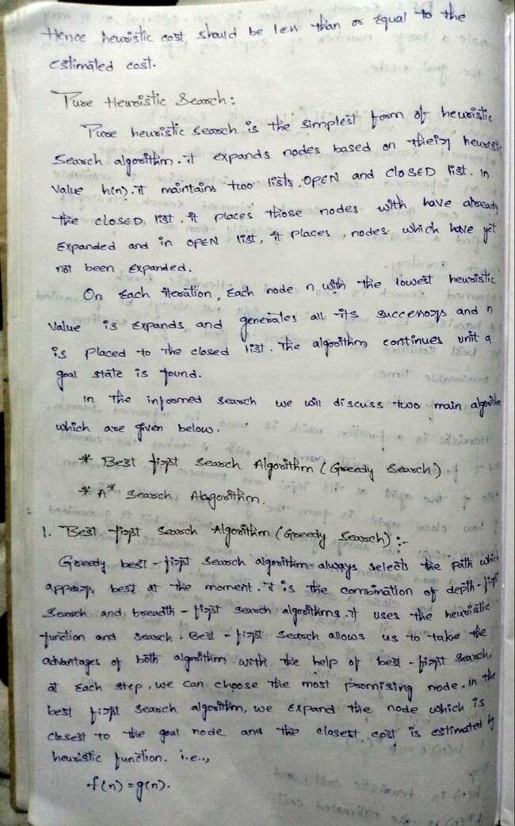

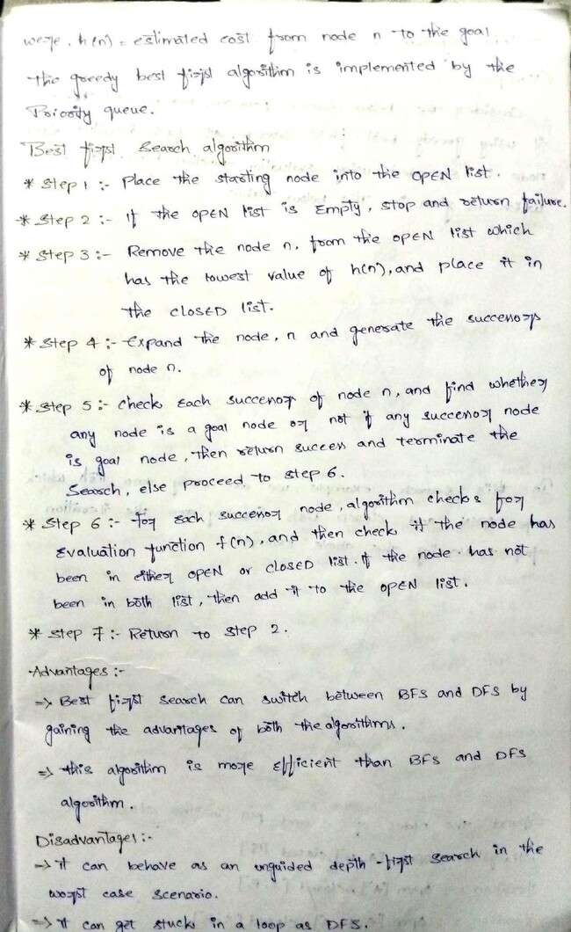

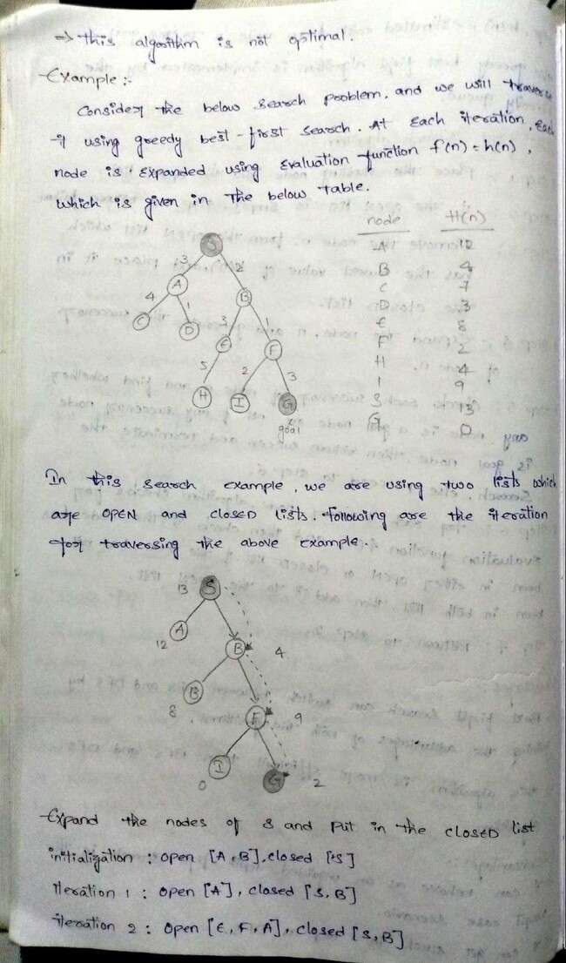

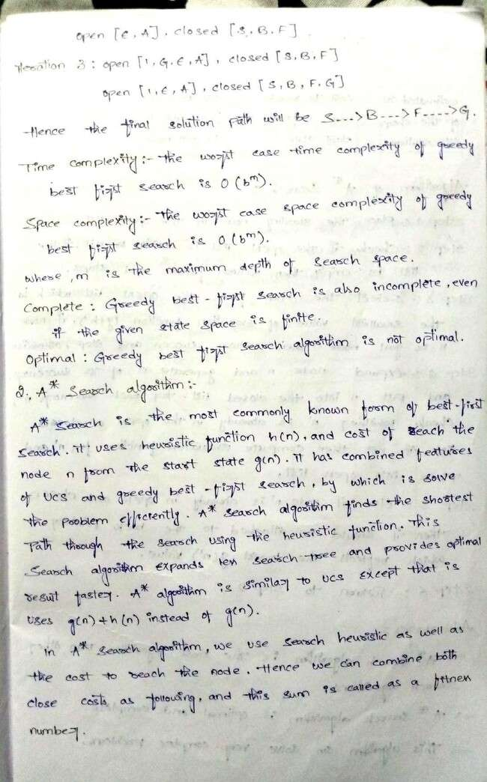

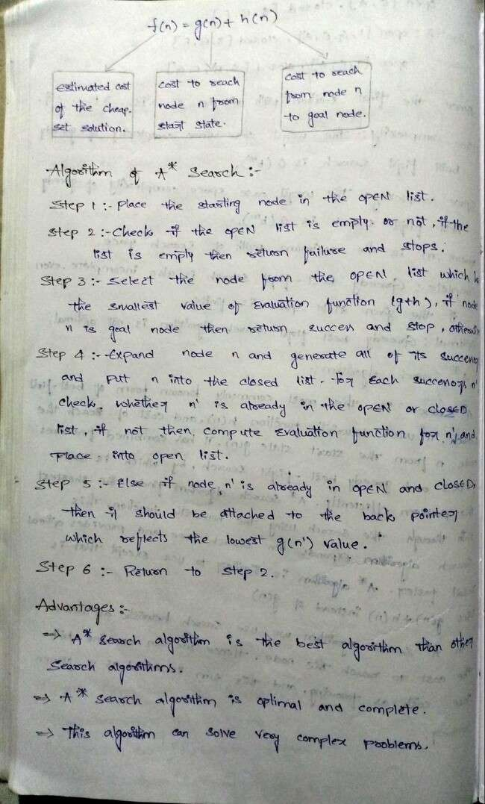

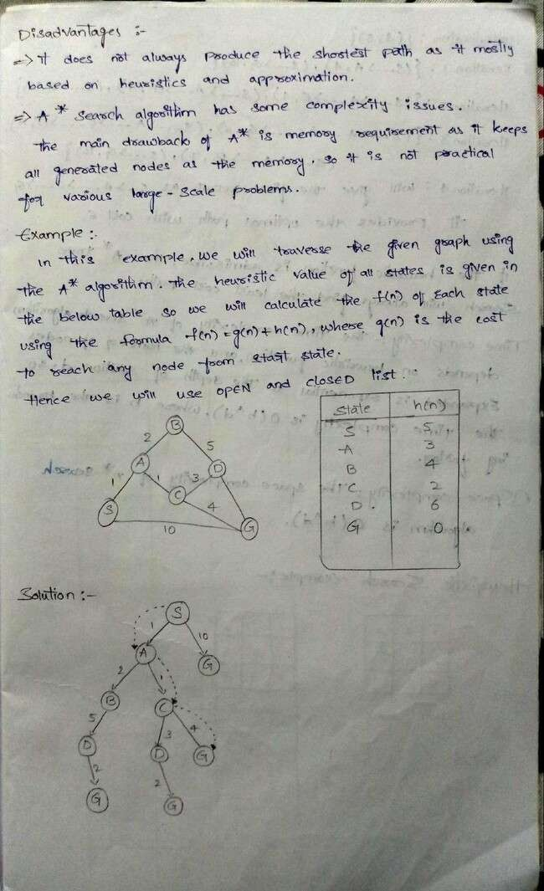

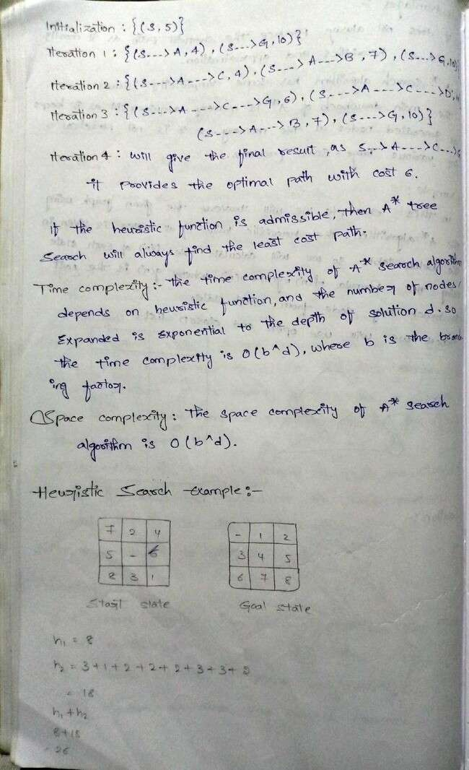

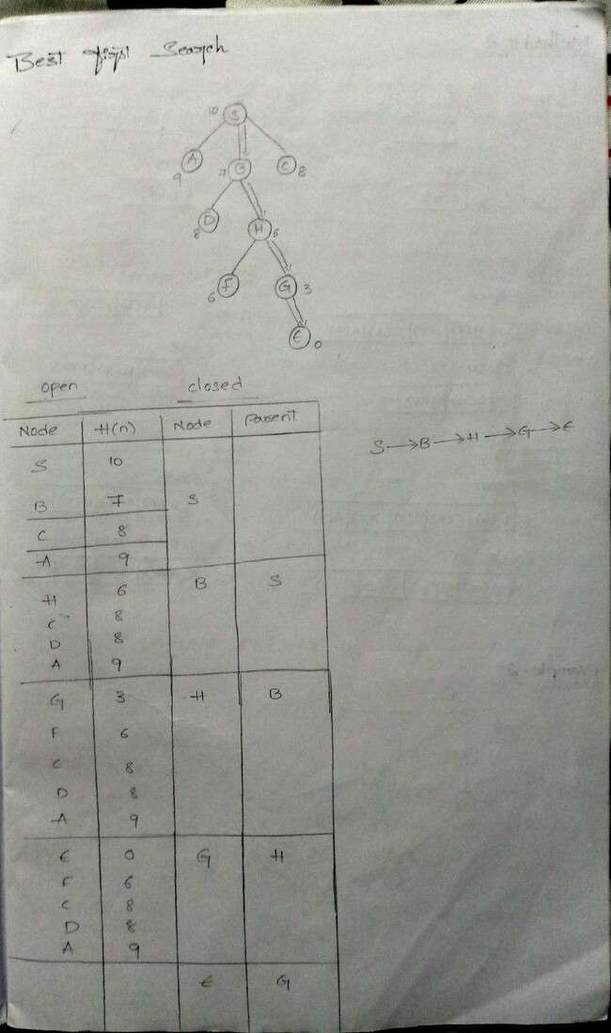

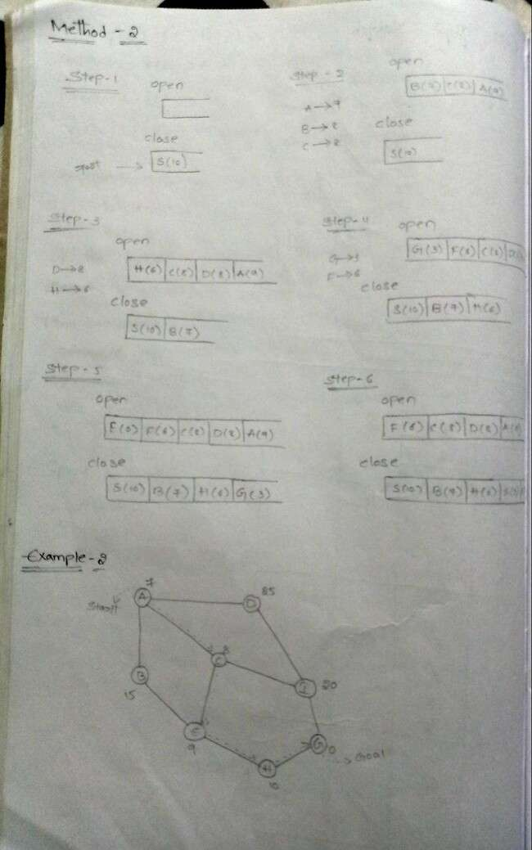

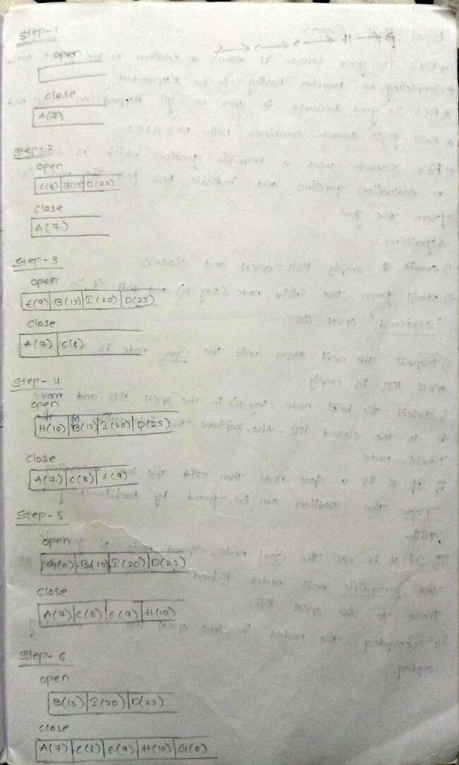

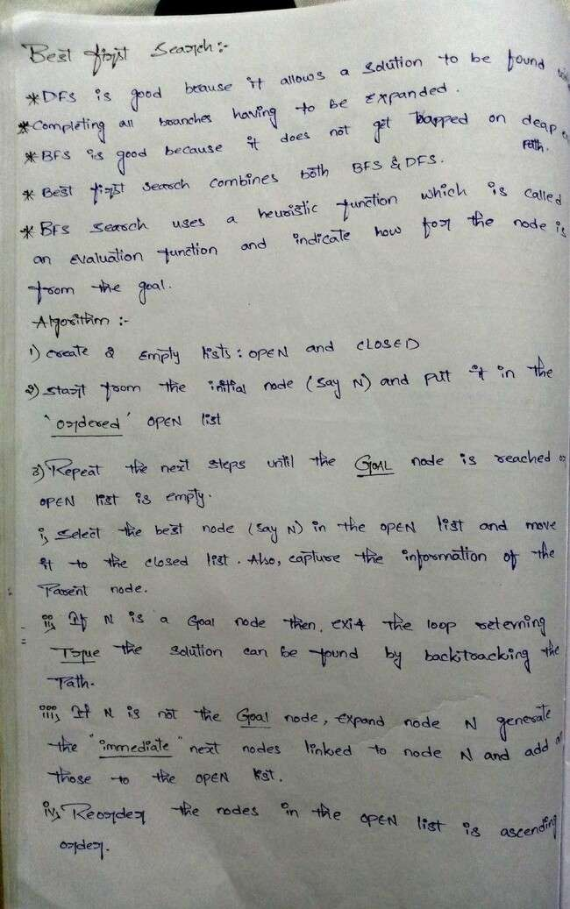

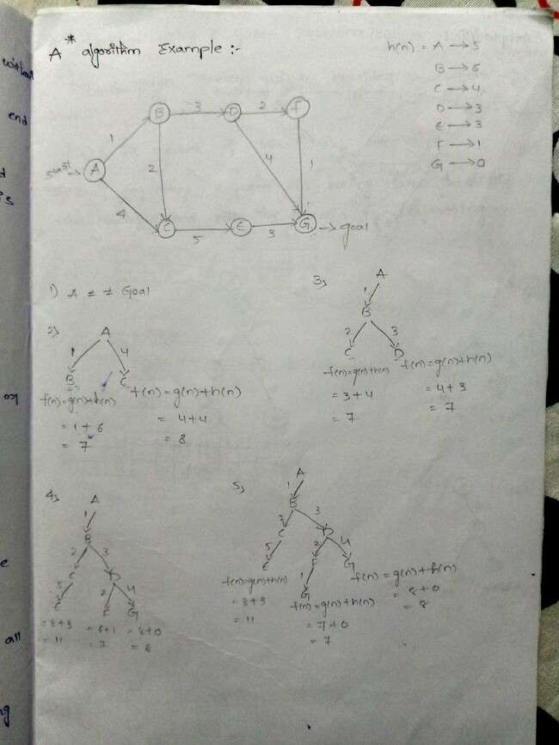

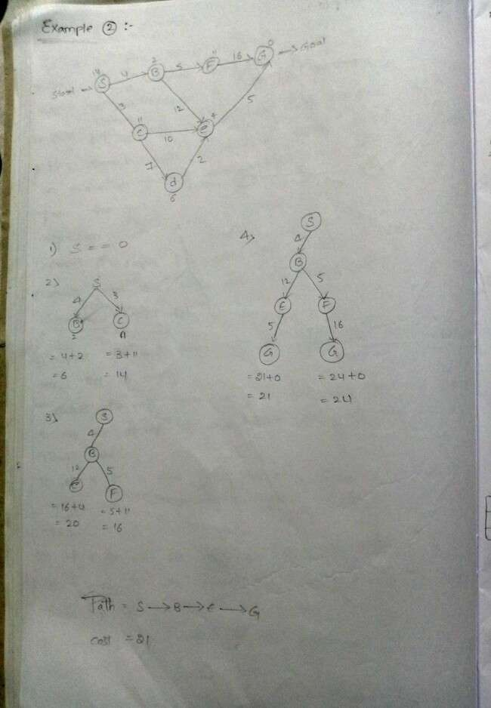

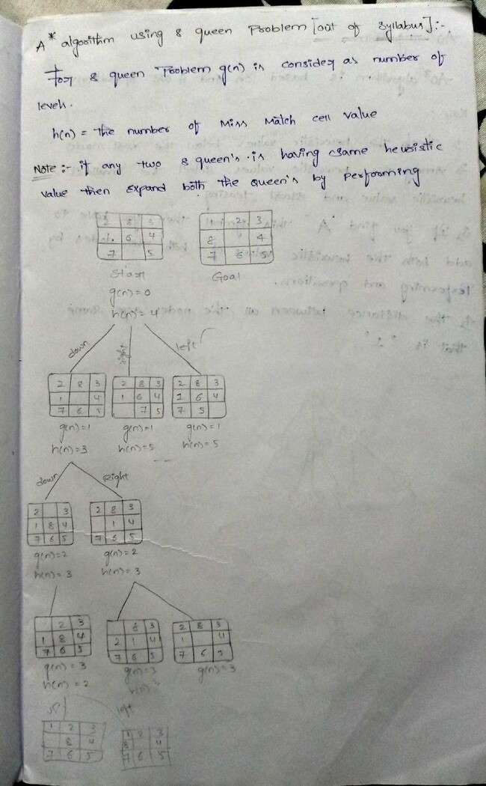

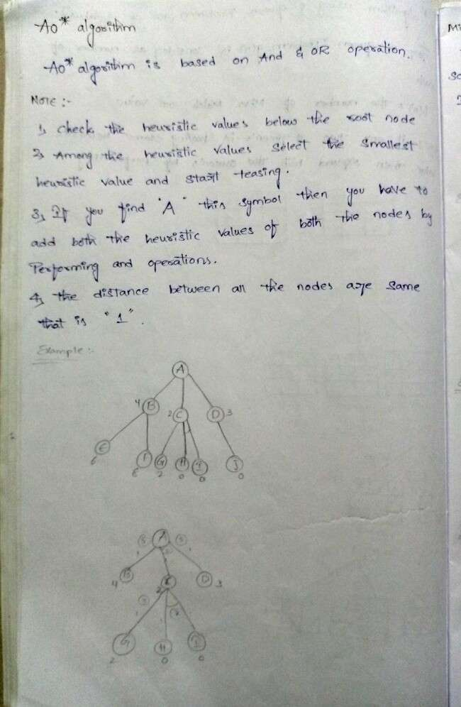

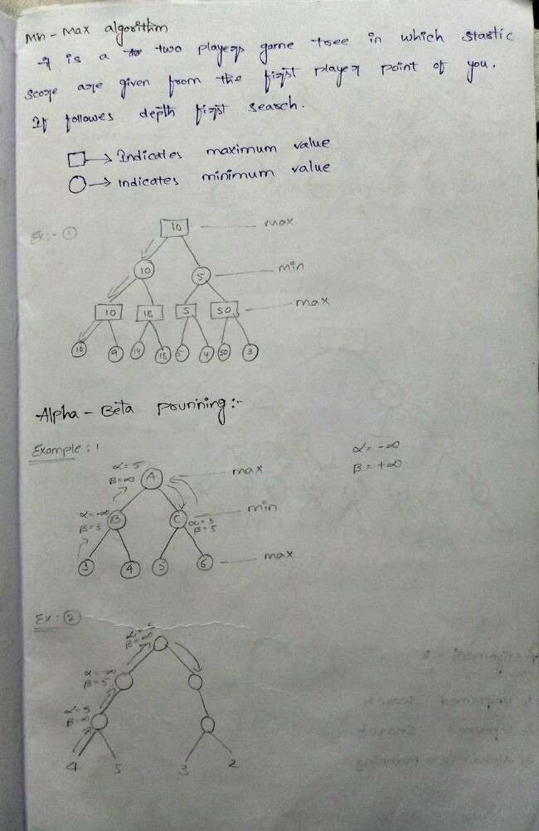

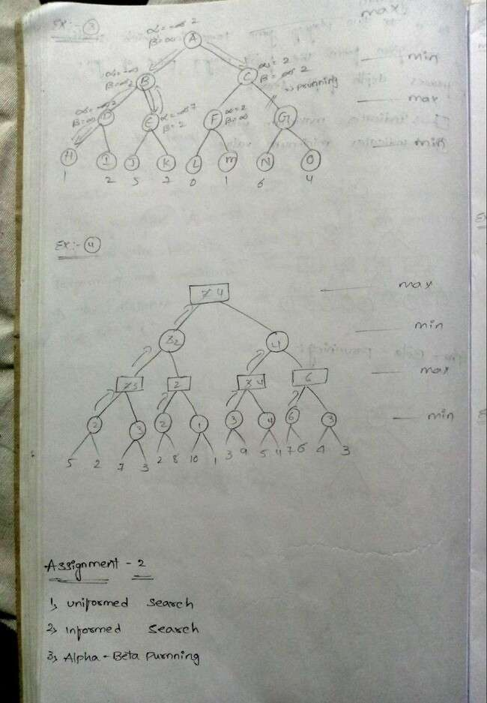

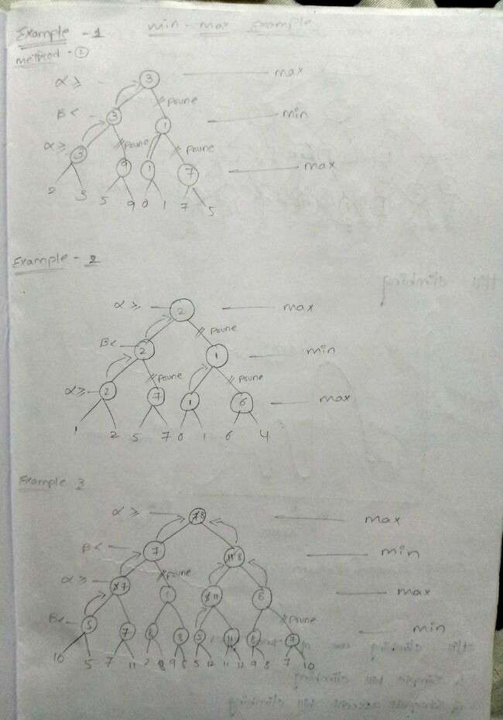

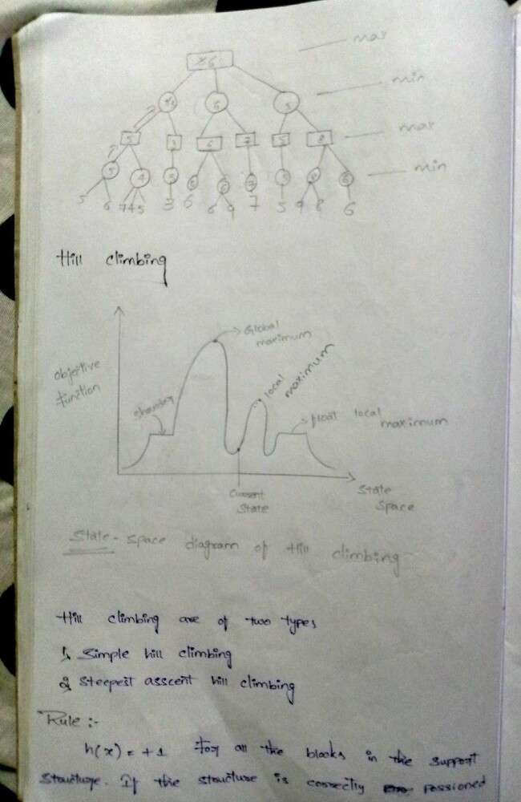

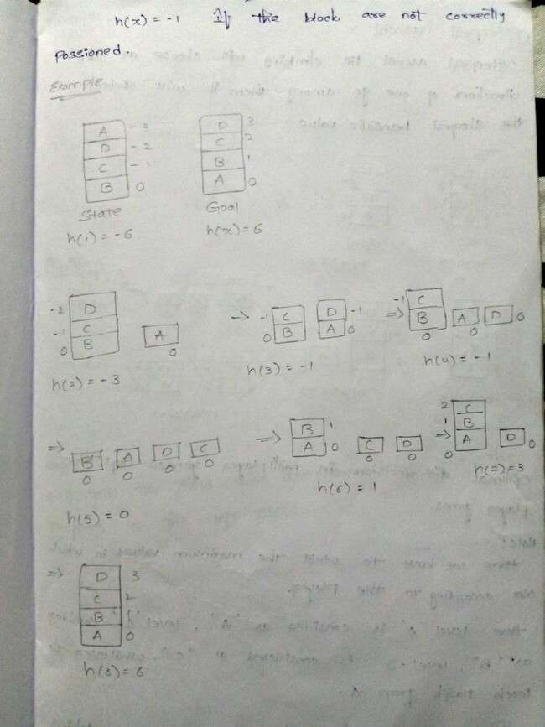

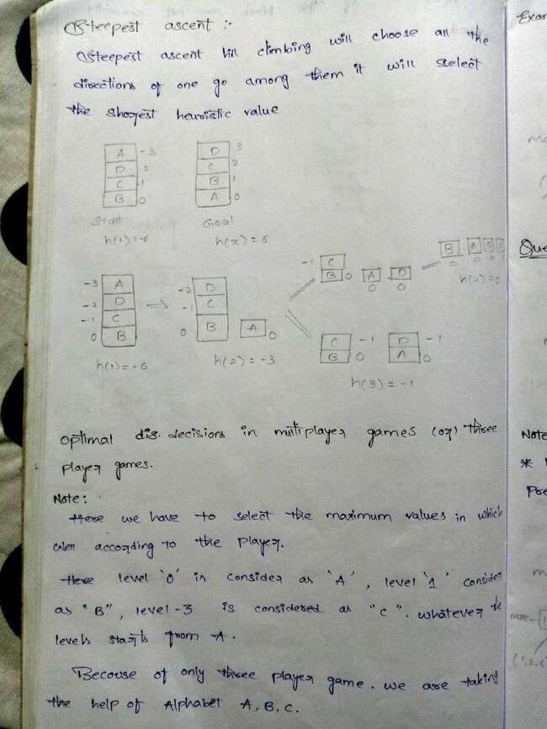

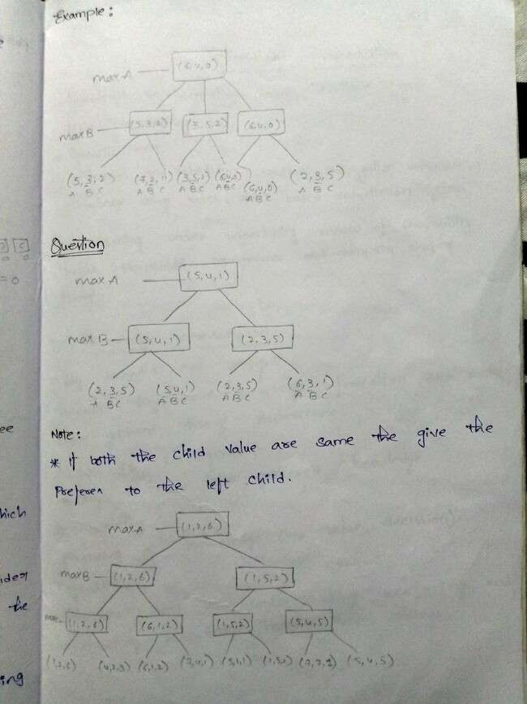

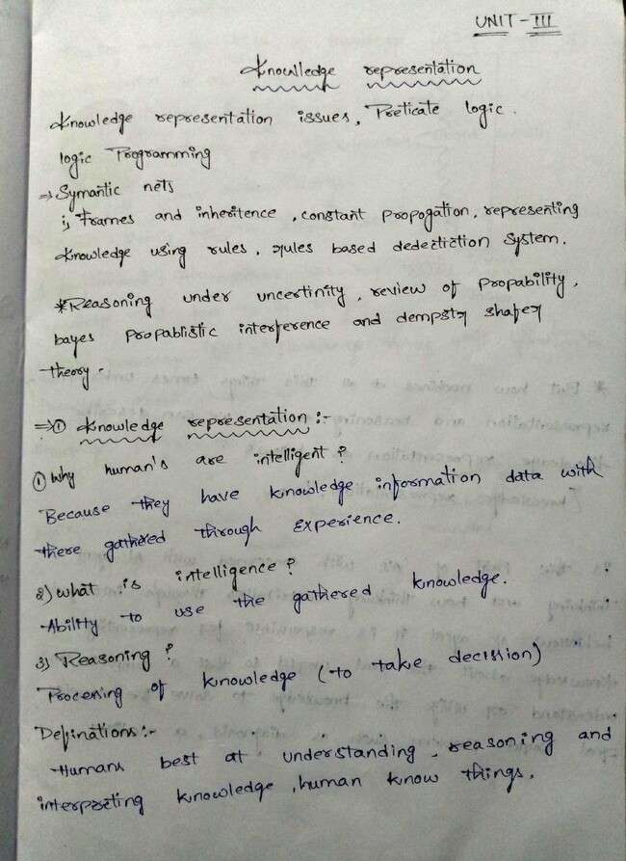

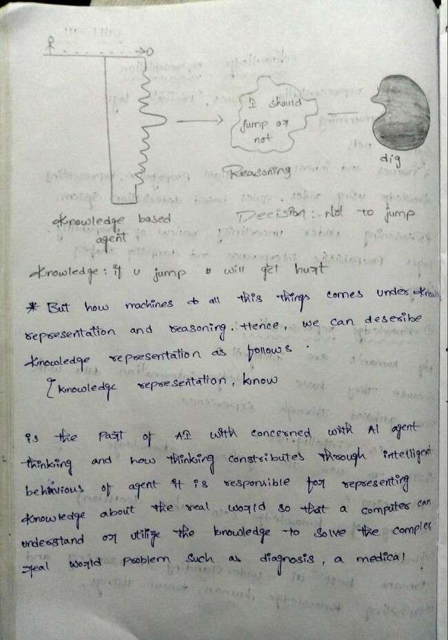

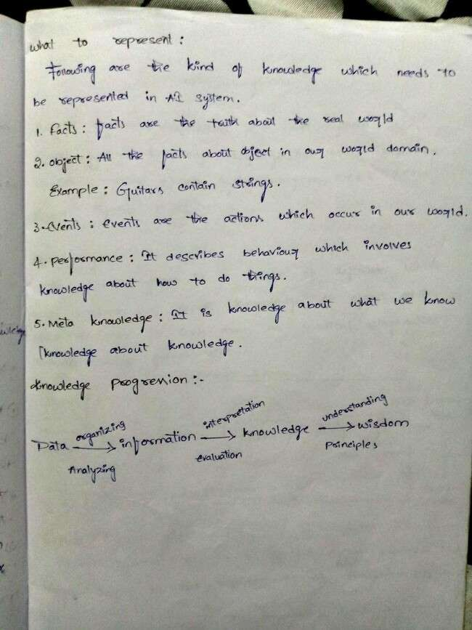

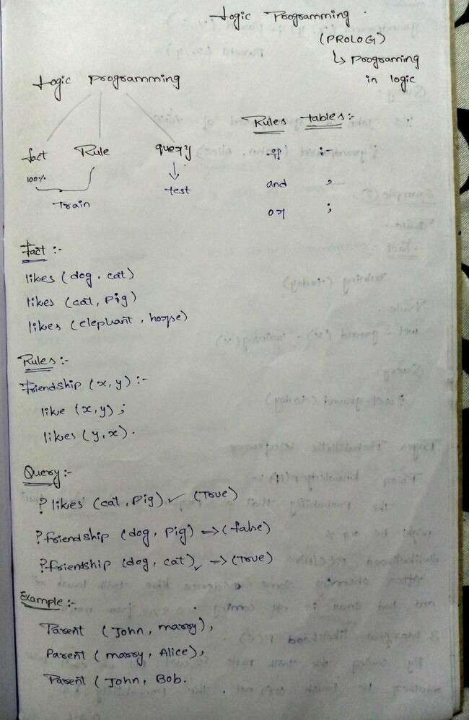

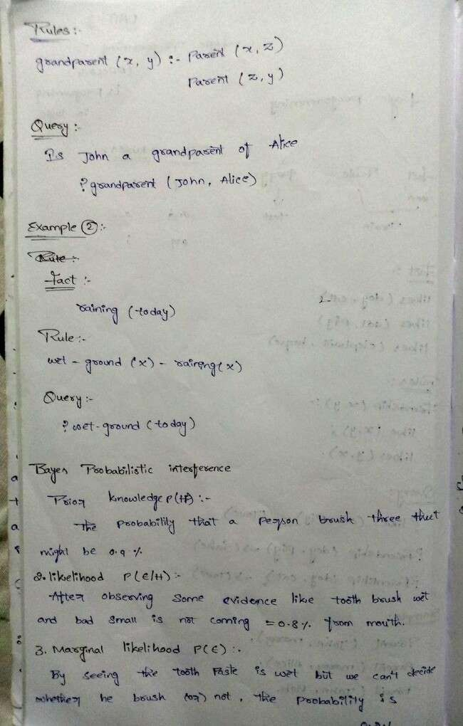

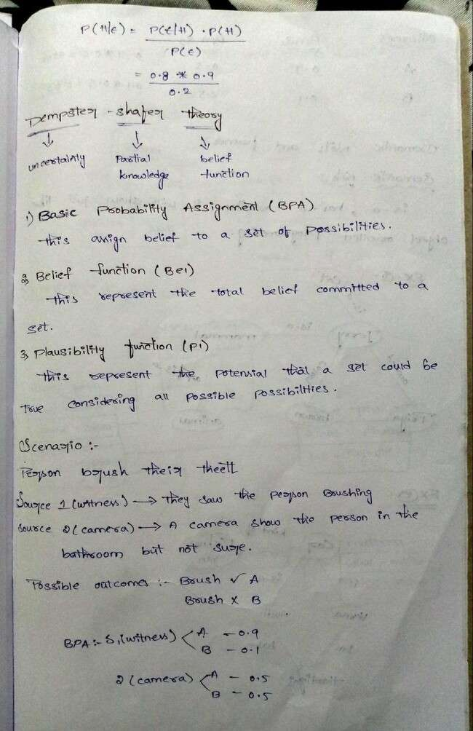

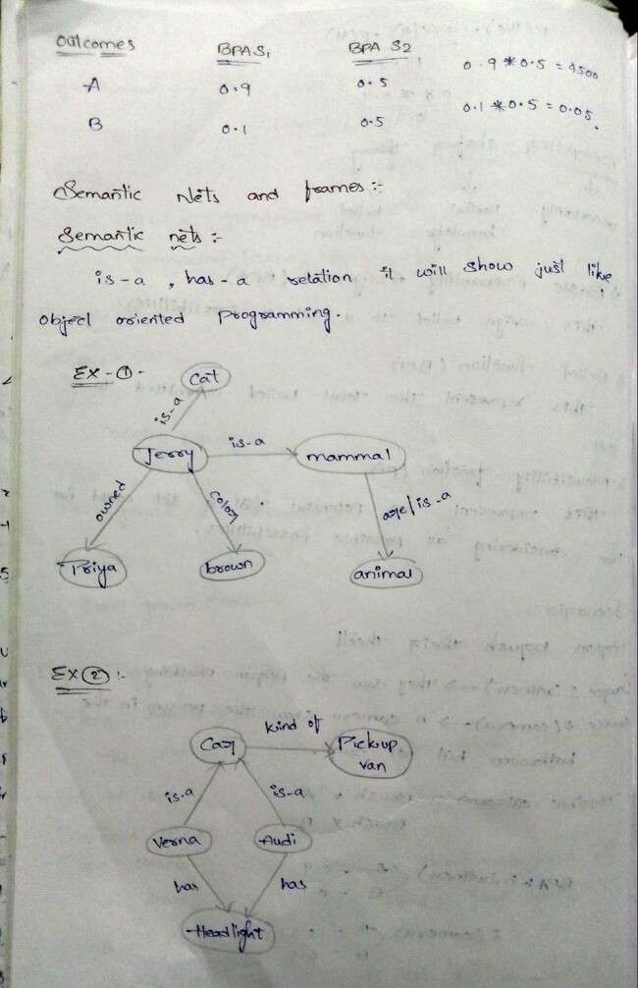

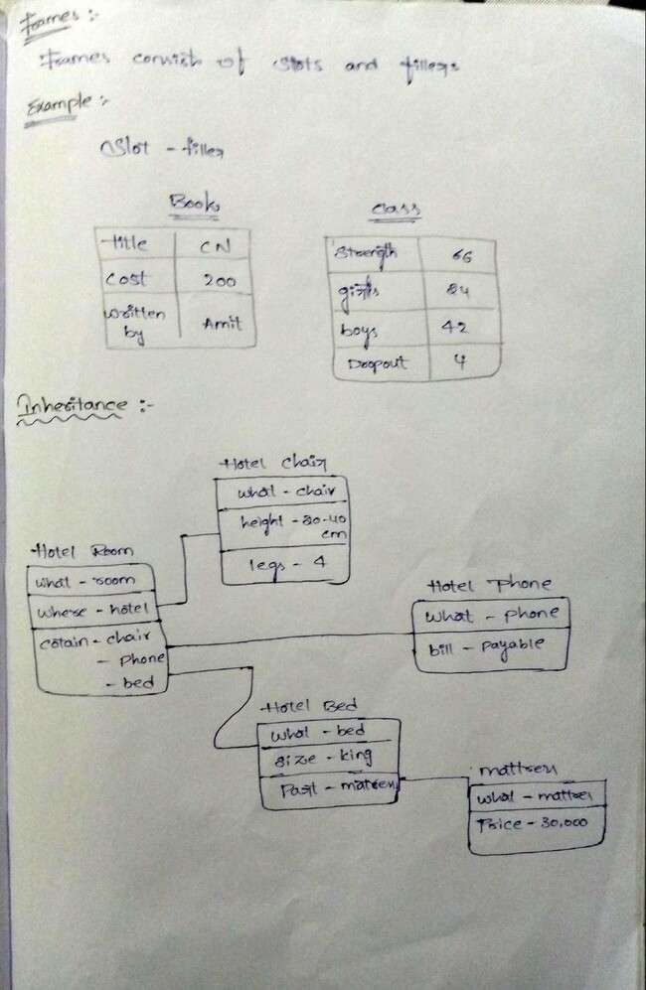

What is Knowledge Representation (KR)?
Knowledge Representation (KR) in Artificial Intelligence (AI) is the process of structuring and storing information so that an AI system can reason, learn, and make decisions. It is a bridge between human understanding and machine processing.
KR is essential for:
- Understanding complex environments (e.g., self-driving cars, medical diagnosis).
- Enabling reasoning and decision-making (e.g., expert systems).
- Storing and retrieving knowledge efficiently (e.g., chatbots, search engines).

Types of Knowledge in AI
AI systems need different types of knowledge, including: Type of Knowledge Example
Declarative Knowledge (facts) "Paris is the capital of France."

Procedural Knowledge (how to do something)
Semantic Knowledge (meaning and relationships)
"To drive, press the gas pedal."

"Dogs are mammals."

Episodic Knowledge (specific events) "I had coffee this morning." Common Sense Knowledge "Water is wet."

Meta-Knowledge (knowledge about knowledge)
"I know that I don’t know this fact."

Approaches to Knowledge Representation
There are several ways AI systems can represent and process knowledge:

KR Approach Description Example

Logical Representation

Semantic Networks
Uses formal logic (propositional & first-order logic).
Graph-based structure with entities and relationships.
If it rains, the ground is wet.

"Cat → is a → Mammal"

Frames Object-oriented structure with attributes and values.
Production Rules IF-THEN rules for decision-making.
Person(Name: Alice, Age: 30, Job: Engineer)
IF temperature > 100°C THEN water boils.

Ontologies
Structured knowledge in hierarchical form (used in the Semantic Web).
Ontology of "Animals" includes "Mammals" and "Birds".

Fuzzy Logic Handles uncertainty using
degrees of truth (0 to 1).
"The room is warm (0.7 truth value)."

Bayesian Networks
Probabilistic models for reasoning under uncertainty.
If a patient has a cough, the probability of flu is 60%.

Example: Knowledge Representation in AI Chatbots Consider an AI chatbot that helps with medical diagnosis. Approach 1: Rule-Based System (Production Rules)
IF fever AND cough THEN flu.
IF sore_throat AND no_fever THEN cold. Approach 2: Semantic Network

Flu → causes → Fever Flu → causes → Cough

Cold → causes → Sore Throat
Approach 3: Bayesian Network (Probabilistic KR)
- P(Flu∣Fever)=0.8P(Flu | Fever) = 0.8P(Flu∣Fever)=0.8
- P(Cold∣SoreThroat)=0.6P(Cold | Sore Throat) = 0.6P(Cold∣SoreThroat)=0.6
The chatbot can reason about symptoms and suggest possible illnesses.

challenges in Knowledge Representation
- Incomplete Knowledge – AI may lack all the facts.
- Uncertainty – Some knowledge is probabilistic (handled by Bayesian Networks, Fuzzy Logic).
- Ambiguity – Natural language is complex (handled by NLP techniques).
- Scalability – Storing vast knowledge efficiently (handled by ontologies and knowledge graphs).

Applications of Knowledge Representation
- Expert Systems – Medical diagnosis (IBM Watson), legal reasoning
- Search Engines – Google Knowledge Graph
- Robotics – Navigation and decision-making
- AI Assistants – Siri, Alexa (understanding context)
- Self-Driving Cars – Recognizing road signs, pedestrians

Constant Propagation
In knowledge representation (KR), constant propagation is a logical optimization technique used to simplify reasoning by replacing known constant values in a knowledge base. This helps in inference, rule-based systems, and automated reasoning.

How Constant Propagation Works in KR
When a fact or rule contains constants, those constants can be propagated through the system to simplify expressions, remove redundant computations, and improve efficiency.

Example in Rule-Based Systems
Consider a Prolog-style knowledge base:
age(john, 30).
age(mary, 25).
is_adult(X) :- age(X, A), A >= 18.
Here, instead of checking A >= 18 every time, we can directly infer:
is_adult(john). % Directly inferred is_adult(mary). % Directly inferred
This avoids unnecessary computations when querying whether someone is an adult.

Example in First-Order Logic (FOL)
Suppose we have a knowledge base:
- father(John)=Robertfather(John) = Robertfather(John)=Robert (John’s father is Robert)
- father(Robert)=Williamfather(Robert) = Williamfather(Robert)=William (Robert’s father is William)
- grandfather(X)=father(father(X))grandfather(X) = father(father(X))grandfather(X)=father(father(X))
Using constant propagation, we can directly derive: grandfather(John)=Williamgrandfather(John) = Williamgrandfather(John)=William
Instead of repeatedly applying the father() function, we replace known constants directly.

Application in AI and Knowledge Graphs
- Semantic Web (RDF & OWL Reasoning)
  - In ontology reasoning, constant propagation simplifies relationships.
  - Example: If hasAge(Alice, 25), then hasAge(Bob, 25) (if Bob and Alice are the same entity).

Expert Systems & Decision Trees
  - Precomputing constant values reduces rule evaluations.
  - Example: A medical expert system with rules:

fever(X) :- temperature(X, T), T > 38.
If temperature(john, 39), it simplifies to fever(john).

Logic Programming (Prolog, Datalog)
  - Directly substitutes values for predicates to avoid redundant computations.

Benefits of Constant Propagation in KR
- Faster inference – Precomputes known values, reducing real-time reasoning workload.
- Memory optimization – Reduces storage by eliminating redundant evaluations.
- Simplifies rule evaluation – Allows efficient decision-making in AI reasoning.

Representing Knowledge Using Rules
In Knowledge Representation (KR), rules are used to encode knowledge in a structured way. Rule-based systems define relationships, constraints, and logical inferences that allow AI systems to reason and derive conclusions.

Types of Rules in Knowledge Representation
1⃣ Production Rules (IF-THEN Rules)
  - Format: IF (condition) THEN (action/conclusion)
  - Used in expert systems and decision-making AI.

Example (Medical Diagnosis Rule)
IF (temperature > 38°C) AND (cough = yes) THEN (diagnosis = "Possible flu")
˙7s•¸.'Implementation in Prolog:
flu(X) :- temperature(X, T), T > 38, cough(X, yes).
–− If John has 39°C temperature and a cough, the system infers flu(john).

2⃣ Derivation Rules (Inference Rules)
  - Used in logical reasoning and knowledge graphs.
  - Helps derive new facts from existing facts.

Example (Family Relationships)
less
IF (parent(X, Y)) AND (parent(Y, Z)) THEN (grandparent(X, Z))
˙s7•.¸' Implementation in Prolog:
grandparent(X, Z) :- parent(X, Y), parent(Y, Z).
–− If Alice is Bob’s parent and Bob is Charlie’s parent, then Alice is Charlie’s grandparent.

3⃣ Constraint Rules
  - Defines what is allowed or restricted in a knowledge base.

Used in AI planning, business rules, and databases.
- Example (Bank Loan Eligibility)
IF (income > $50,000) AND (credit_score > 700) THEN (loan_approved = yes)
.¸•s7˙'Implementation in SQL-like Rule System:
sql
SELECT customer_id FROM applicants
WHERE income > 50000 AND credit_score > 700;

4️⃣ Fuzzy Rules (For Handling Uncertainty)
  - Used in fuzzy logic systems to deal with imprecise data.
  - Instead of strict "yes/no," it considers degrees of truth.

Example (Fan Speed Control Based on Temperature)
csharp
IF (temperature is high) THEN (fan_speed is fast)
˙7•.s¸' Fuzzy Logic Example:
python
import skfuzzy as fuzz

temperature = fuzz.trimf([30, 40, 50])
fan_speed = fuzz.trimf([0, 50, 100])
–− This allows gradual adjustment rather than an abrupt ON/OFF decision.

Applications of Rule-Based Knowledge Representation
- Expert Systems (e.g., MYCIN for medical diagnosis)
- Chatbots & Virtual Assistants (e.g., rule-based responses in AI bots)
- Semantic Web & Ontologies (e.g., RDF, OWL for knowledge graphs)
- Business Rule Management Systems (e.g., Drools, IBM Operational Decision Manager)
- AI Planning & Robotics (e.g., decision-making in self-driving cars)

Rule-Based Deduction System in Knowledge Representation
A Rule-Based Deduction System is a knowledge-based system that derives new facts from existing facts using rules and logical inference. It is widely used in expert systems, AI reasoning, and automated decision-making.

Key Components of a Rule-Based Deduction System
1⃣ Knowledge Base (KB) – Contains facts and rules.
2⃣ Inference Engine – Applies rules to known facts to derive new facts.
3⃣ Working Memory – Stores intermediate facts generated during reasoning.
4⃣ User Interface – Allows interaction with the system.

How Rule-Based Deduction Works
  - Rules are written in IF-THEN format.
  - The inference engine applies forward or backward chaining to derive conclusions.

Types of Rule-Based Deduction
1⃣ Forward Chaining (Data-Driven Inference)
  - Starts with known facts and applies rules to infer new facts.
  - Used in expert systems and automated reasoning.

Example: Diagnosing a Disease Facts:
fever(john). cough(john). Rule:
IF (fever(X) AND cough(X)) THEN flu(X).
¸˙7s•.'Prolog Implementation:
flu(X) :- fever(X), cough(X).
–− Query: ?- flu(john).
- Output: Yes (because John has fever and cough).

2⃣ Backward Chaining (Goal-Driven Inference)
  - Starts with a goal and works backwards to find supporting facts.
  - Used in theorem proving and logic programming (e.g., Prolog).

Example: Checking if John has the flu Goal: flu(john)?
- The system checks: Does John have fever and cough?
- If facts exist → Conclude flu(john).
- If facts do not exist → Ask user or perform further deductions.
˙•7¸s.'Prolog Example (Backward Chaining)
flu(X) :- fever(X), cough(X). fever(john).
cough(john).
–− Query: ?- flu(john).
- Output: Yes (because Prolog checks rules recursively).

Applications of Rule-Based Deduction Systems
- Expert Systems – MYCIN (Medical Diagnosis), CLIPS (Decision Making)
- AI Chatbots – Rule-based conversational AI
- Theorem Provers – Prolog, Automated Reasoning Systems
- Semantic Web & Ontologies – RDF, OWL reasoning
- Business Rule Engines – Drools, IBM Operational Decision Manager

Advantages & Disadvantages
- Advantages:
Transparent reasoning process Easy to modify rules
Suitable for well-defined domains

+ Disadvantages:
+ Cannot handle uncertainty well (unless fuzzy logic is used)
+ Computationally expensive for large knowledge bases
+ Hard to scale for complex real-world scenarios

Reasoning Under Uncertainty in Knowledge Representation
In Knowledge Representation (KR), reasoning under uncertainty deals with situations where facts and rules are incomplete, imprecise, or uncertain. Traditional logic-based systems (like Prolog) work well with definite knowledge, but real-world scenarios (e.g., medical diagnosis, self-driving cars, AI assistants) require handling probabilistic and fuzzy information.

Types of Uncertainty in Knowledge Representation
1⃣ Probability-Based Uncertainty (e.g., Bayesian Networks)
2⃣ Fuzzy Logic (e.g., Handling vague concepts like "tall" or "hot")
3⃣ Non-Monotonic Reasoning (e.g., Default and belief-based reasoning)
4⃣ Dempster-Shafer Theory (e.g., Combining evidence from multiple sources) 5⃣ Possibility Theory (e.g., Alternative to probability for handling vagueness)

Methods for Reasoning Under Uncertainty
1⃣ Bayesian Networks (Probabilistic Reasoning)
  - Uses probabilities to model uncertainty.
  - Based on Bayes' Theorem: P(H∣E)=P(E∣H)P(H)P(E)P(H|E) = \frac{P(E|H) P(H)}{P(E)}P(H∣E)=P(E)P(E∣H)P(H) Where:
    - P(H∣E)P(H|E)P(H∣E) = Probability of hypothesis HHH given evidence EEE.
    - P(E∣H)P(E|H)P(E∣H) = Likelihood of evidence if HHH is true.

    - P(H)P(H)P(H) = Prior probability of HHH.

Example: Medical Diagnosis
If 80% of flu patients have a fever, and 5% of the general population has a fever, we can compute:
P(Flu∣Fever)=(0.8∗0.1)/0.05=0.16P(Flu | Fever) = (0.8 * 0.1) / 0.05 = 0.16 P(Flu∣Fever)=(0.8∗0.1)/0.05=0.16
Applications: AI-based diagnosis, spam detection, robotics.

2⃣ Fuzzy Logic (Handling Vagueness and Approximation)
  - Used when information is not binary (True/False) but gradual (0 to 1).
  - Example:
    - Crisp Logic: Temperature > 30°C → "Hot" (Strict condition).
    - Fuzzy Logic: Temperature = 28°C → "Moderately Hot" (Partial truth).

Example: Controlling a Fan Based on Temperature
IF temperature is HIGH THEN fan speed is FAST.
˙7s¸.•'Python Example using skfuzzy
import skfuzzy as fuzz import numpy as np

temperature = np.arange(20, 41, 1)
hot = fuzz.trimf(temperature, [30, 35, 40]) print(hot) # Membership values for "hot" category
Applications: AI controllers, robotics, recommendation systems.

3⃣ Non-Monotonic Reasoning (Default & Belief-Based Reasoning)
  - In classical logic, once something is proven, it never changes.
  - In non-monotonic reasoning, new evidence can retract conclusions.

Example: Bird & Flight Assumption
IF X is a bird THEN X can fly.
IF X is a penguin THEN X cannot fly.
If we first assume "Tweety is a bird," we conclude "Tweety can fly."
Later, if we learn "Tweety is a penguin," we revise our belief and conclude "Tweety cannot fly."
•s7˙.'¸Prolog Implementation (Non-Monotonic Logic)

flies(X) :- bird(X), \+ penguin(X). bird(tweety).
penguin(tweety).
–− Query: ?- flies(tweety).
- Output: No (because Tweety is a penguin).
Applications: AI planning, knowledge graphs, dynamic decision-making.

4️⃣ Dempster-Shafer Theory (Evidence-Based Reasoning)
  - Used when probabilities are unknown, but we have belief and doubt.
  - Allows combining evidence from multiple sources.

Example: Identifying an Object Based on Two Sensors
Sensor A: 60% confidence it's a car. Sensor B: 50% confidence it's a car.
Combined belief using Dempster's Rule: 75%.
Applications: Sensor fusion, fraud detection, AI-based surveillance.

Comparison of Uncertainty Handling Methods

Method | Best For | Example Use Case
Bayesian Networks | Probabilistic reasoning | Medical diagnosis, spam filters
Fuzzy Logic | Approximate reasoning | AI controllers, smart home systems
Non-Monotonic Logic | Revising beliefs | AI planning, expert systems
Dempster-Shafer | Combining evidence | Multi-sensor fusion, cybersecurity

Bayesian Probabilistic Inference and Dempster-Shafer Theory
Bayesian inference and Dempster-Shafer theory are two key reasoning under uncertainty
approaches in knowledge representation (KR).

1⃣ Bayesian Probabilistic Inference

Bayesian inference is based on Bayes' theorem, which updates the probability of a hypothesis as new evidence appears.

Bayes' Theorem:
P(H∣E)=P(E∣H)⋅P(H)P(E)P(H|E) = \frac{P(E|H) \cdot P(H)}{P(E)}P(H∣E)=P(E)P(E∣H)⋅P(H)
Where:
  - P(H∣E)P(H|E)P(H∣E) = Probability of hypothesis HHH given evidence EEE (posterior).
  - P(E∣H)P(E|H)P(E∣H) = Probability of evidence given hypothesis (likelihood).
  - P(H)P(H)P(H) = Prior probability of the hypothesis.
  - P(E)P(E)P(E) = Total probability of the evidence. Example: Medical Diagnosis
Let’s say a doctor wants to determine if a patient has flu (HHH) based on the symptom fever (EEE).
  - Prior Probability P(H)P(H)P(H) = 10% (1 in 10 people have the flu).
  - Likelihood P(E∣H)P(E|H)P(E∣H) = 80% (80% of flu patients have fever).
  - Evidence Probability P(E)P(E)P(E) = 5% (5% of the population has fever). Using Bayes' Theorem:
P(Flu∣Fever)=0.8×0.10.05=0.16P(Flu | Fever) = \frac{0.8 \times 0.1}{0.05} = 0.16P(Flu∣Fever)=0.050.8×0.1=0.16
–− The probability that a patient has the flu given that they have a fever is 16%.
- Applications: Medical diagnosis, spam filters, recommendation systems, robotics.

2⃣ Dempster-Shafer Theory (Evidence Theory)
Dempster-Shafer theory (DST) is a generalization of probability theory that deals with uncertainty and incomplete knowledge. Unlike Bayes' Theorem, DST does not require prior probabilities and allows for "degrees of belief" based on evidence.

Key Concepts in Dempster-Shafer Theory
  - Belief function Belief(A)Belief(A)Belief(A): The degree of confidence in A being true.
  - Plausibility function Plausibility(A)Plausibility(A)Plausibility(A): The maximum possible belief in A (accounts for unknowns).
  - Mass function m(A)m(A)m(A): A function that assigns belief masses to different subsets of the hypothesis space.

Dempster’s Rule of Combination
If two independent sources give mass functions m1m_1m1 and m2m_2m2, the combined belief is:

m(A)=∑X∩Y=Am1(X)⋅m2(Y)1−Km(A) = \frac{\sum_{X \cap Y = A} m_1(X) \cdot m_2(Y)}{1 - K}m(A)=1−K∑X∩Y=Am1(X)⋅m2(Y)
where KKK represents the conflict between the two sources.

Example: Identifying an Object Based on Two Sensors
Imagine two sensors trying to identify whether an object is a car (C) or a bike (B):

Sensor A:
    - 60% sure it's a car.
    - 30% sure it's a bike.
    - 10% uncertainty.

Sensor B:
    - 50% sure it's a car.
    - 40% sure it's a bike.
    - 10% uncertainty.
Using Dempster’s Rule, we combine the belief values to get a final updated belief for each possibility.
- Applications: Sensor fusion, AI decision-making, fraud detection, autonomous vehicles.

Comparison: Bayesian Inference vs. Dempster-Shafer Theory
Feature Bayesian Inference Dempster-Shafer Theory
Requires Prior
Probabilities? ⬛ Yes + No
Handles Uncertainty? ⬛ Yes, using probabilities ⬛ Yes, using belief functions

Deals with Missing
Information? + No (needs prior data) ⬛ Yes (supports unknowns)
Mathematical Complexity Moderate Higher
Combining Evidence Uses conditional probabilities Uses Dempster’s Rule

Best Used For Probabilistic reasoning (e.g., medical AI)
Multi-source evidence fusion (e.g., sensor AI)

Note:

- Use Bayesian Networks if you have prior probabilities and want probabilistic reasoning.
- Use Dempster-Shafer Theory if you want to combine uncertain evidence from multiple sources

without needing priors.

Simple example for students

Bayesian Probabilistic Inference: "Brush Teeth" Example
Bayesian probabilistic inference helps us make decisions based on prior knowledge and new evidence. Let’s apply Bayes’ Theorem to the everyday habit of brushing teeth and its relationship with having fresh breath.

1⃣ Problem Statement: Does Fresh Breath Indicate That a Person Brushed Their Teeth?

Let:

- HHH = Person brushed their teeth
- EEE = Person has fresh breath

We want to compute P(H|E), the probability that a person brushed their teeth given that they have fresh breath.

Bayes' Theorem Formula:
P(H∣E)=P(E∣H)⋅P(H)P(E)P(H|E) = \frac{P(E|H) \cdot P(H)}{P(E)}P(H∣E)=P(E)P(E∣H)⋅P(H)

Assume the following probabilities:
- Prior Probability P(H)P(H)P(H) (chance that a person brushed their teeth) = 0.8 (80%)
- Likelihood P(E∣H)P(E|H)P(E∣H) (probability of fresh breath if they brushed) = 0.9 (90%)
- Total Probability of Fresh Breath P(E)P(E)P(E):

Fresh breath can also occur if they used mouthwash or chewed gum
  - Suppose 10% of people don't brush but still have fresh breath
  - Then: P(E)=P(E∣H)P(H)+P(E∣¬H)P(¬H)P(E) = P(E|H)P(H) + P(E|\neg H)P(\neg
H)P(E)=P(E∣H)P(H)+P(E∣¬H)P(¬H) P(E)=(0.9×0.8)+(0.1×0.2)=0.72+0.02=0.74P(E) = (0.9
\times 0.8) + (0.1 \times 0.2) = 0.72 + 0.02 = 0.74P(E)=(0.9×0.8)+(0.1×0.2)=0.72+0.02=0.74

2⃣ Apply Bayes' Theorem

P(H∣E)=0.9×0.80.74=0.720.74=0.973P(H|E) = \frac{0.9 \times 0.8}{0.74} = \frac{0.72}{0.74} = 0.973P(H∣E)=0.740.9×0.8=0.740.72=0.973
–− If a person has fresh breath, there is a 97.3% probability that they brushed their teeth.

Real-Life Applications of Bayesian Inference
  - Medical AI – Diagnosing diseases based on symptoms
  - Spam Filters – Determining if an email is spam based on keywords
  - AI Assistants – Making smart decisions based on user behavior
  - Self-Driving Cars – Assessing road conditions based on sensor data

Dempster-Shafer Theory (DST) with "Brush Teeth" Example:
Dempster-Shafer Theory (DST) is used for reasoning under uncertainty, especially when multiple sources provide partial or conflicting evidence. Unlike Bayesian inference, DST does not require prior probabilities and allows for degrees of belief and uncertainty.

1⃣ Problem Statement: Did a Person Brush Their Teeth?
We have two independent sources of evidence:
- A camera in the bathroom that may have recorded the person brushing.
- A witness (e.g., roommate) who may have seen the person brushing.
Each source provides some belief, doubt, and uncertainty about whether the person brushed their teeth.

2⃣ Assigning Mass Functions to Evidence Sources
We define three hypotheses:
  - B (Brushed Teeth)
  - ~B (Did NOT Brush Teeth)
  - U (Uncertainty / Don't Know)

Belief Masses from the Two Evidence Sources
- Camera Evidence
Hypothesis Belief Mass (m1) Brushed Teeth (B) 0.7
Did NOT Brush (~B) 0.1 Uncertainty (U) 0.2
- Witness Testimony
Hypothesis Belief Mass (m2) Brushed Teeth (B) 0.6
Did NOT Brush (~B) 0.2 Uncertainty (U) 0.2
Each source has some uncertainty, as the camera might not have captured everything, and the witness might be mistaken.

Combine Evidence Using Dempster’s Rule
Dempster’s Rule of Combination:
m(A)=∑X∩Y=Am1(X)⋅m2(Y)1−Km(A) = \frac{\sum_{X \cap Y = A} m_1(X) \cdot m_2(Y)}{1 - K}m(A)=1−K∑X∩Y=Am1(X)⋅m2(Y)
where KKK represents the conflict between the sources.

Step 1: Compute Raw Beliefs
Multiplying mass functions for all possible intersections:

Combined Hypothesis

Brushed Teeth (B)

Did NOT Brush (~B)
Computation

(0.7×0.6)+(0.7×0.2)+(0.6×0.2)=0.42+0.14+0.12=0.68(0.7 \times 0.6) + (0.7 \times 0.2)
+ (0.6 \times 0.2) = 0.42 + 0.14 + 0.12 =
0.68(0.7×0.6)+(0.7×0.2)+(0.6×0.2)=0.42+0.14+0.12=0.68

(0.1×0.2)=0.02(0.1 \times 0.2) = 0.02(0.1×0.2)=0.02

Uncertainty (U)
(0.2×0.2)+(0.2×0.1)=0.04+0.02=0.06(0.2 \times 0.2) + (0.2 \times 0.1) = 0.04 + 0.02 =
0.06(0.2×0.2)+(0.2×0.1)=0.04+0.02=0.06

Combined Hypothesis
Computation

Conflict (K) (0.7×0.2)+(0.1×0.6)=0.14+0.06=0.2(0.7 \times 0.2) + (0.1 \times 0.6) = 0.14 + 0.06 =
0.2(0.7×0.2)+(0.1×0.6)=0.14+0.06=0.2

Step 2: Normalize by (1 - Conflict)
K=0.2K = 0.2K=0.2
Final adjusted beliefs:
  - Brushed Teeth (B) = 0.68/(1−0.2)=0.850.68 / (1 - 0.2) = 0.850.68/(1−0.2)=0.85
  - Did NOT Brush (~B) = 0.02/(1−0.2)=0.0250.02 / (1 - 0.2) = 0.0250.02/(1−0.2)=0.025
  - Uncertainty (U) = 0.06/(1−0.2)=0.0750.06 / (1 - 0.2) = 0.0750.06/(1−0.2)=0.075

Final Result:
  - 85% belief that the person brushed their teeth
+ 2.5% belief that they did NOT brush
^˙±'•·˜·˙7.5% uncertainty remains

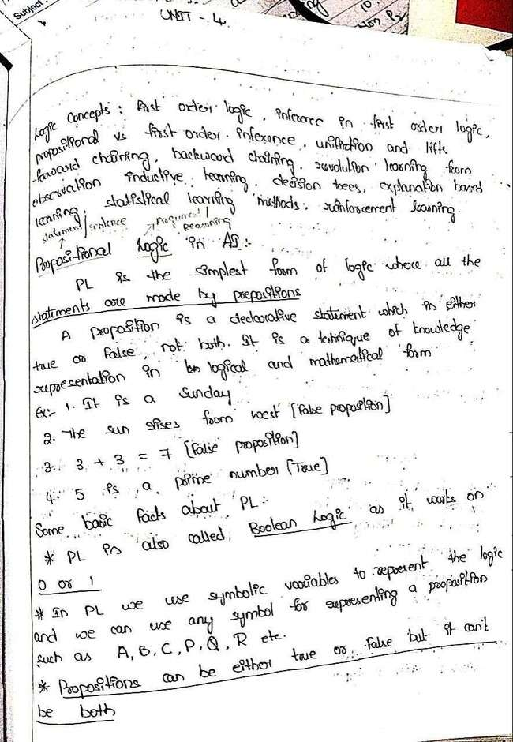

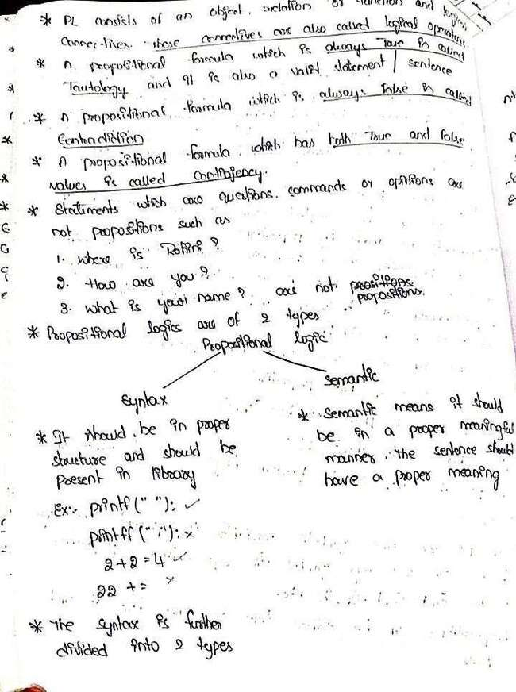

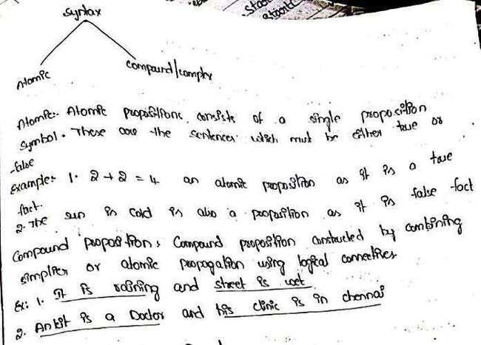

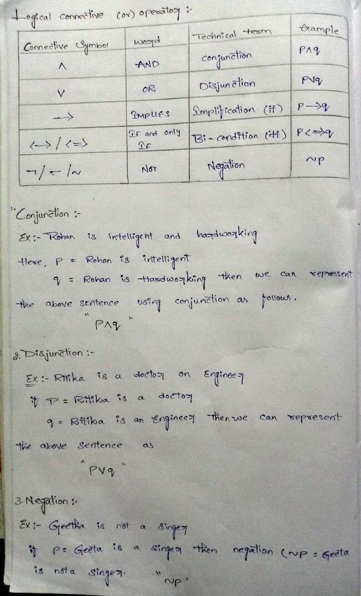

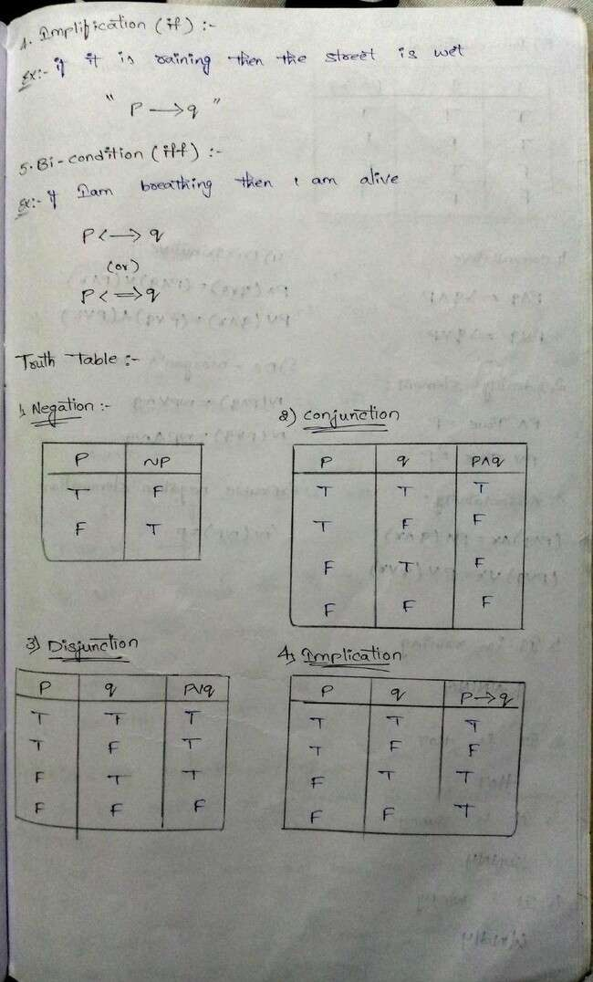

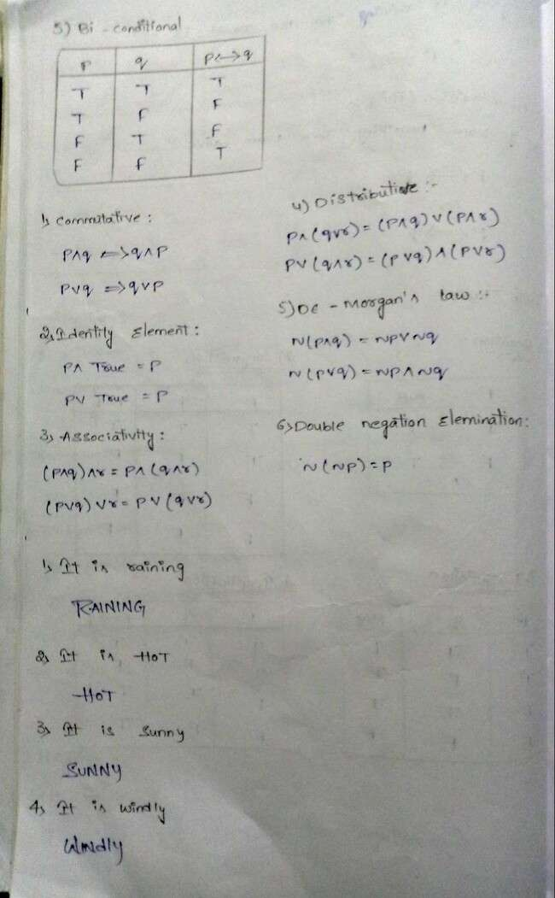

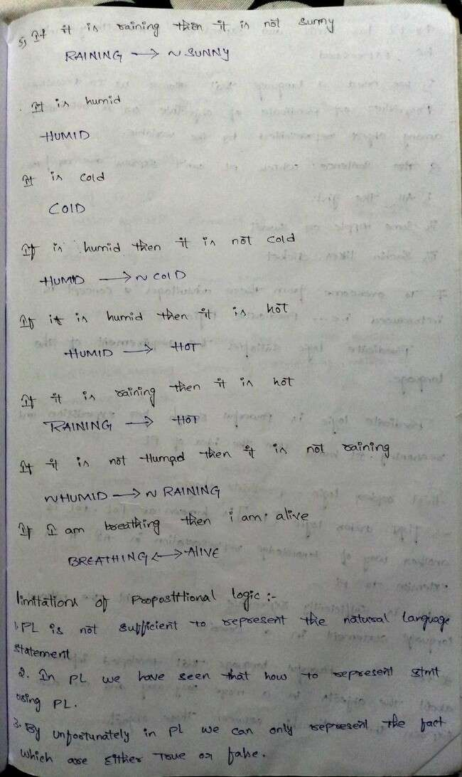

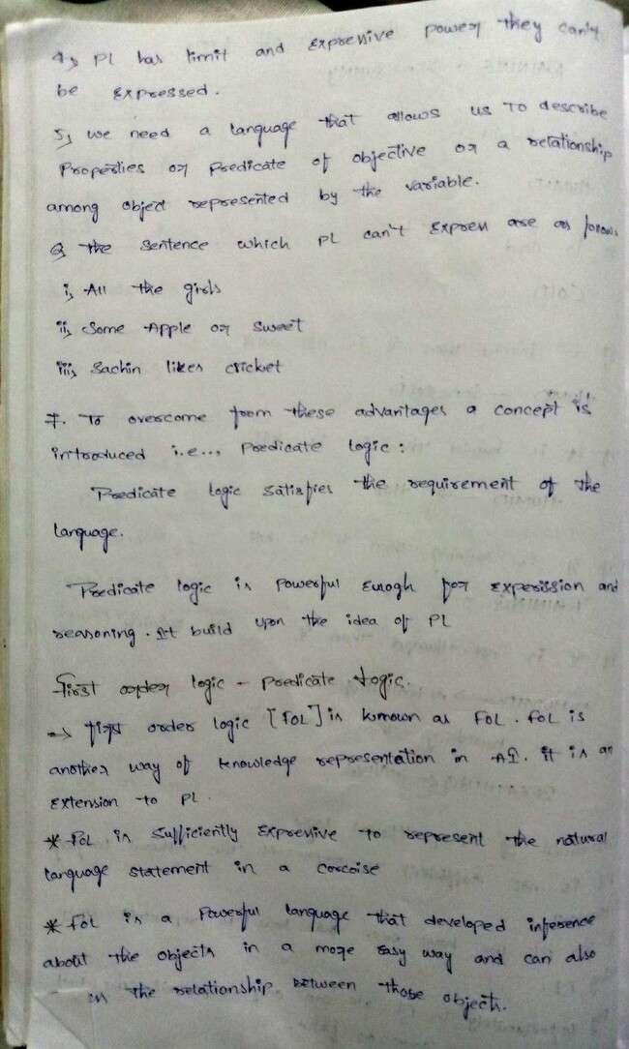

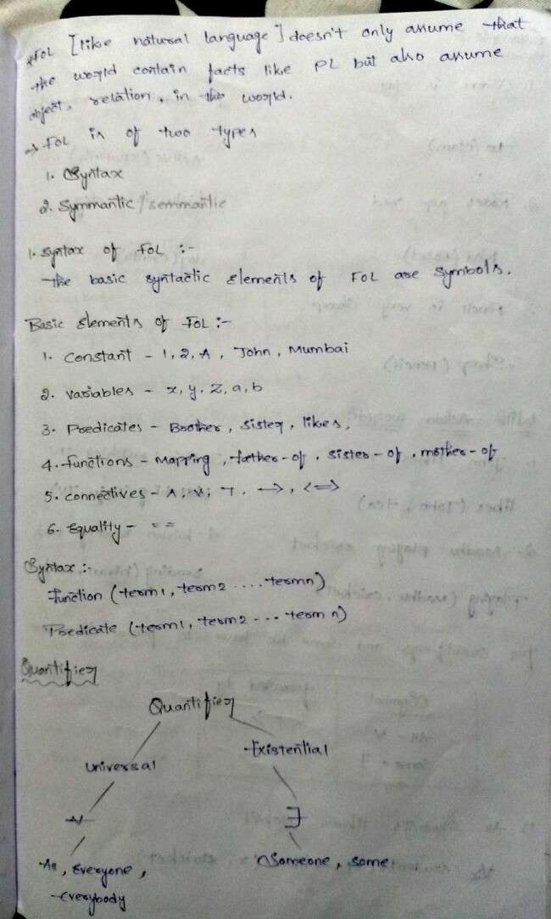

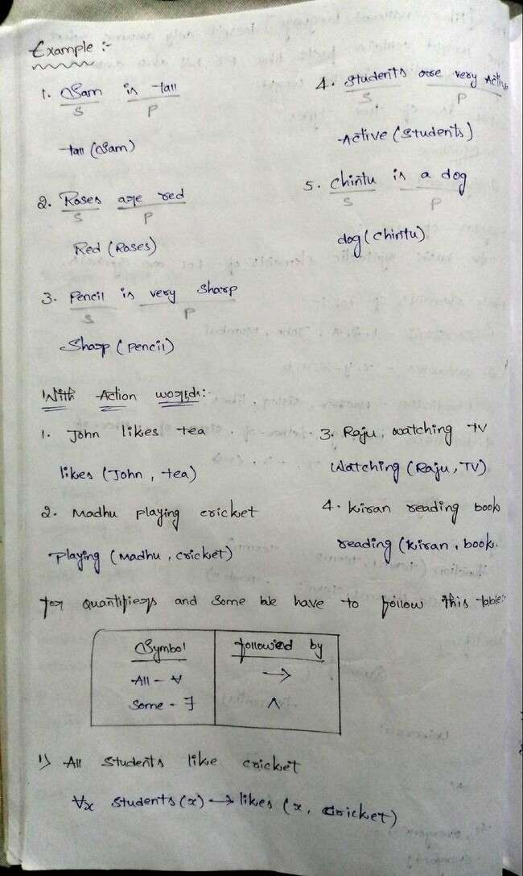

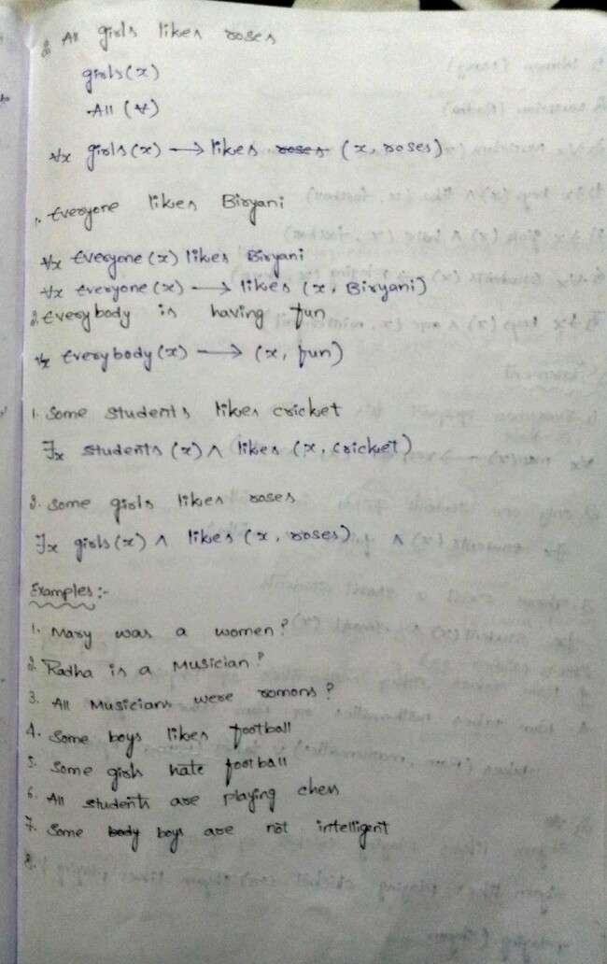

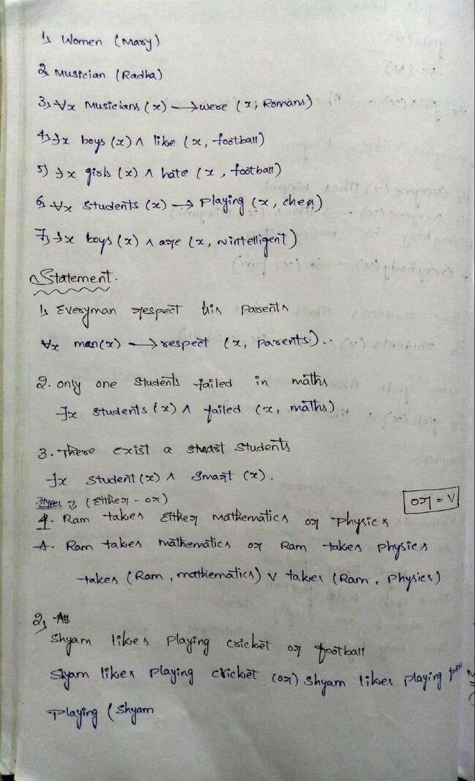

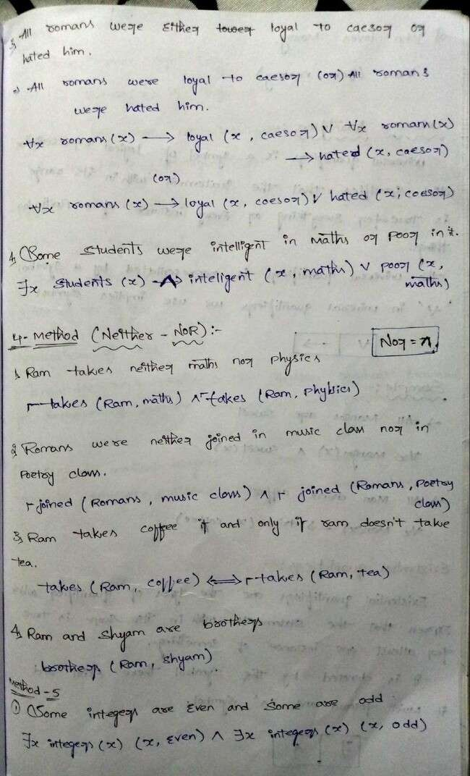

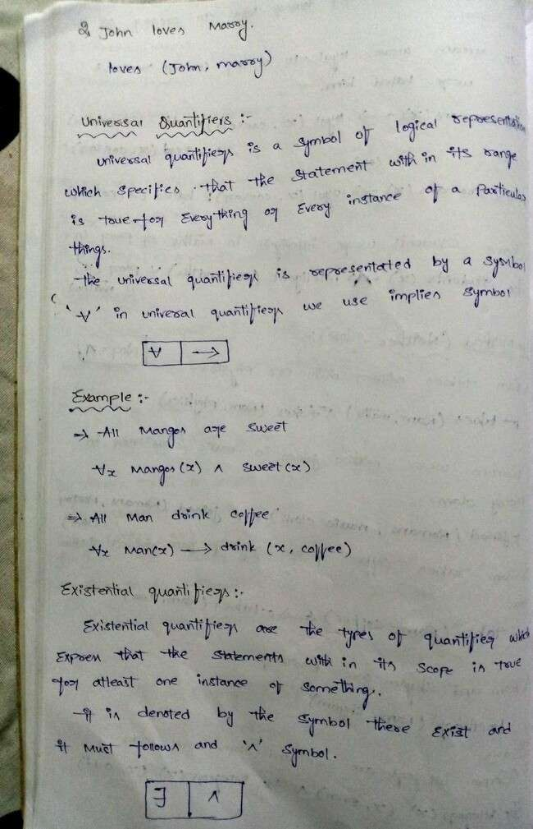

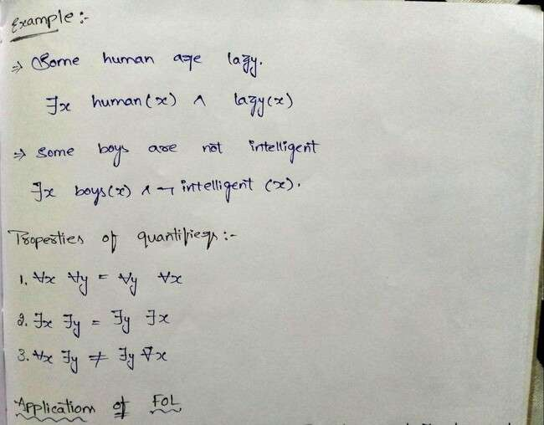

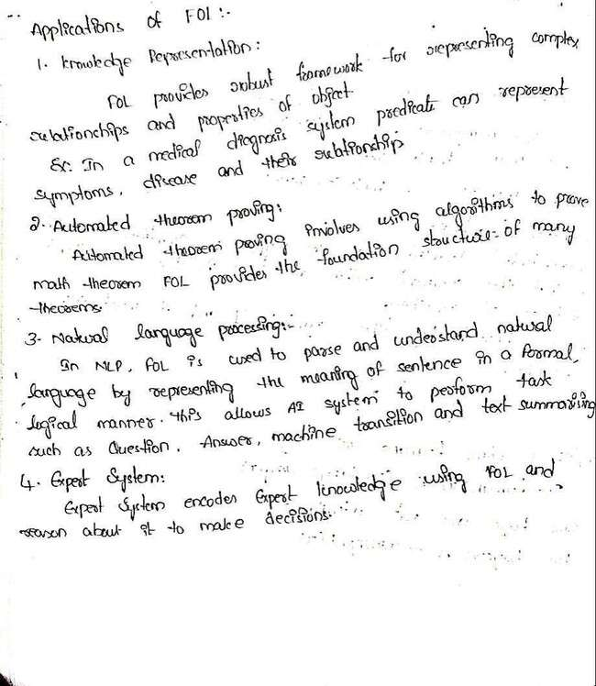

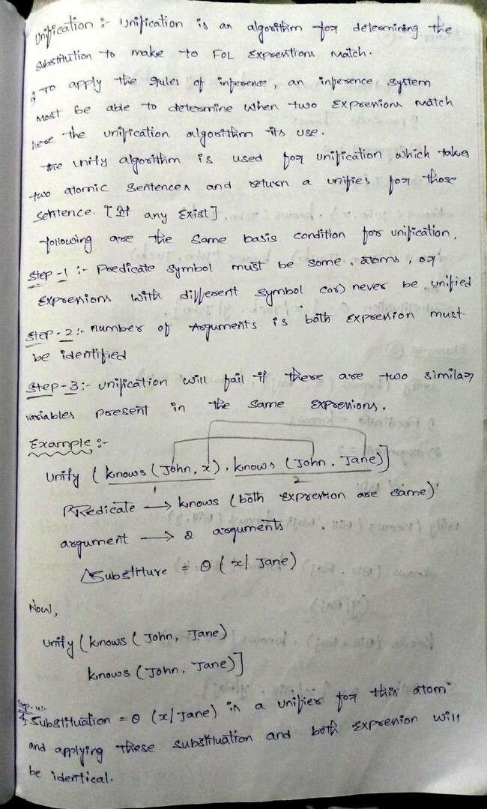

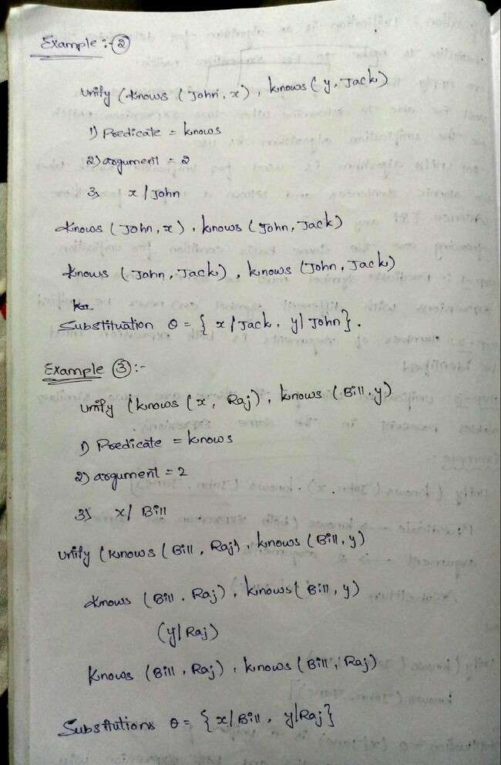

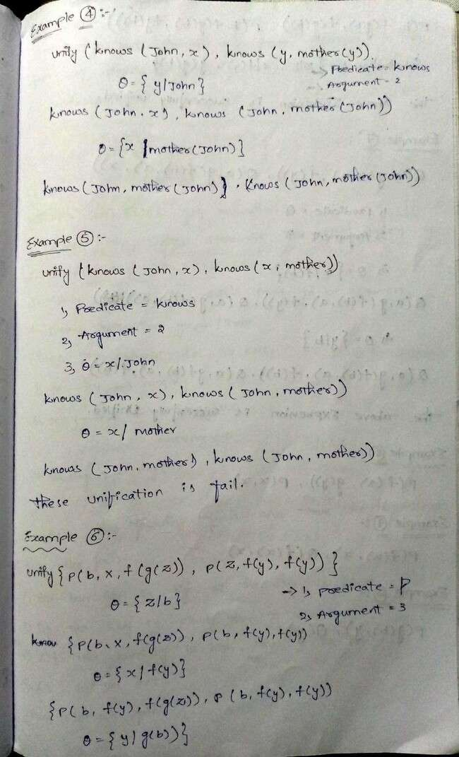

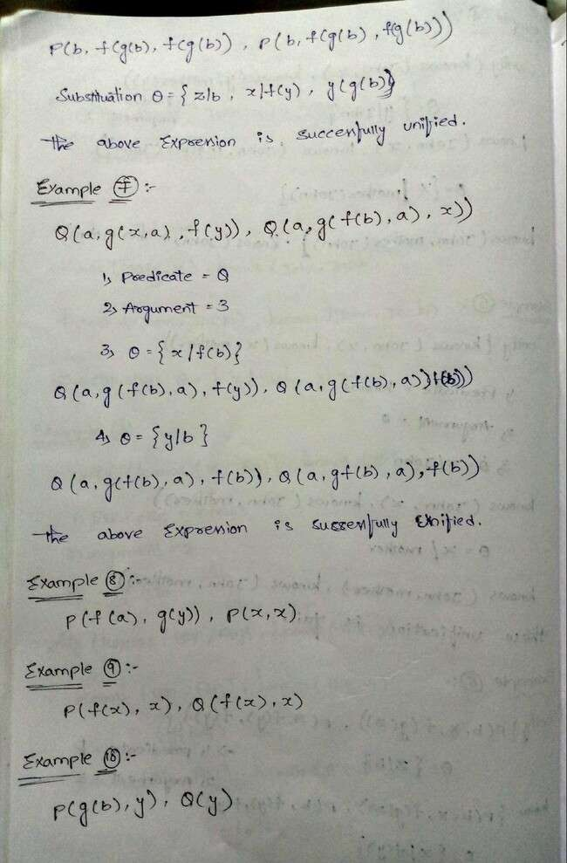

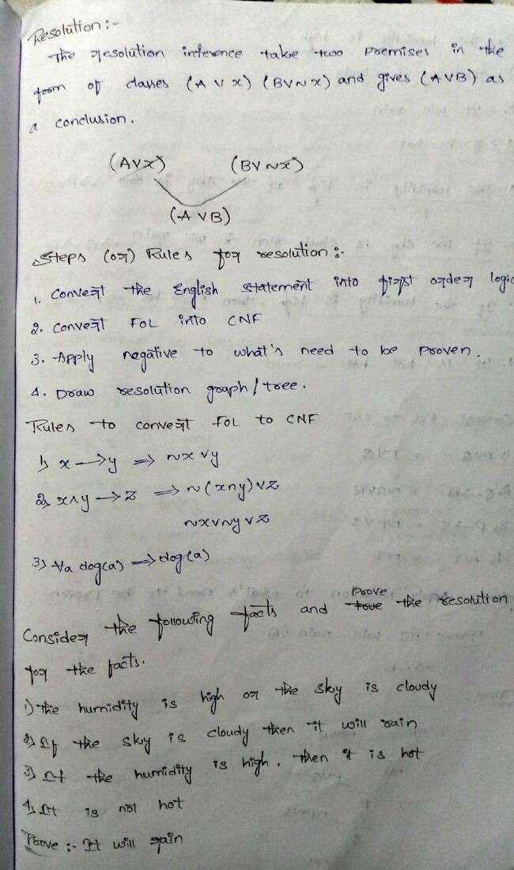

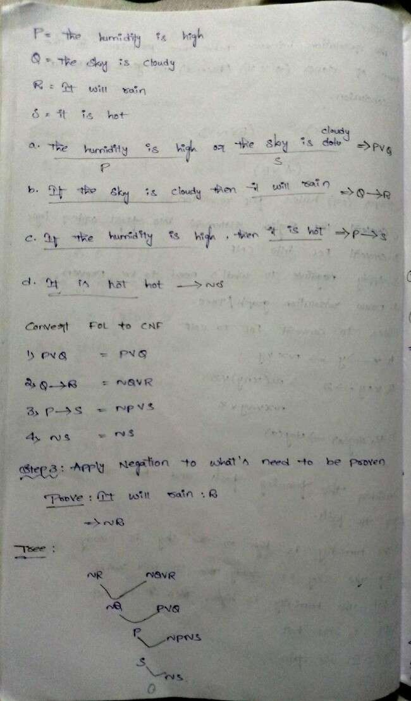

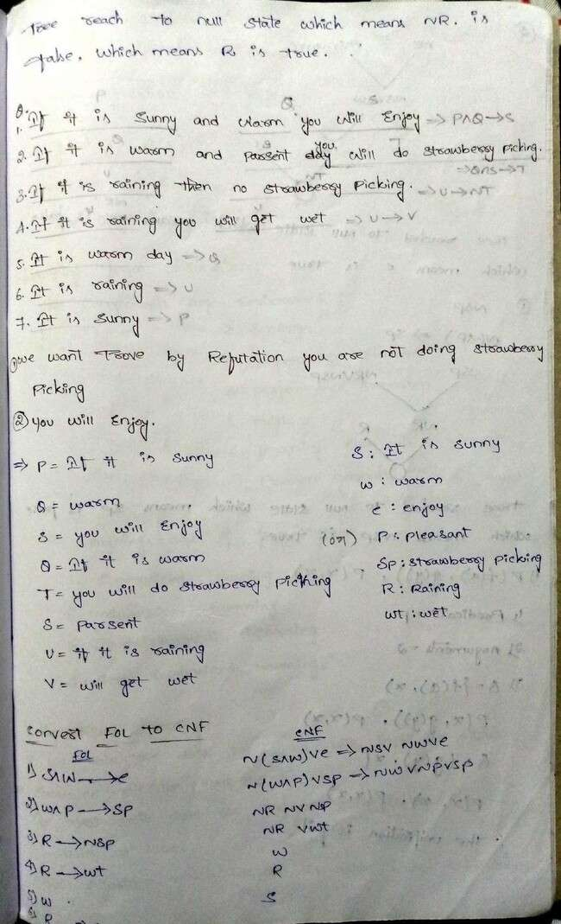

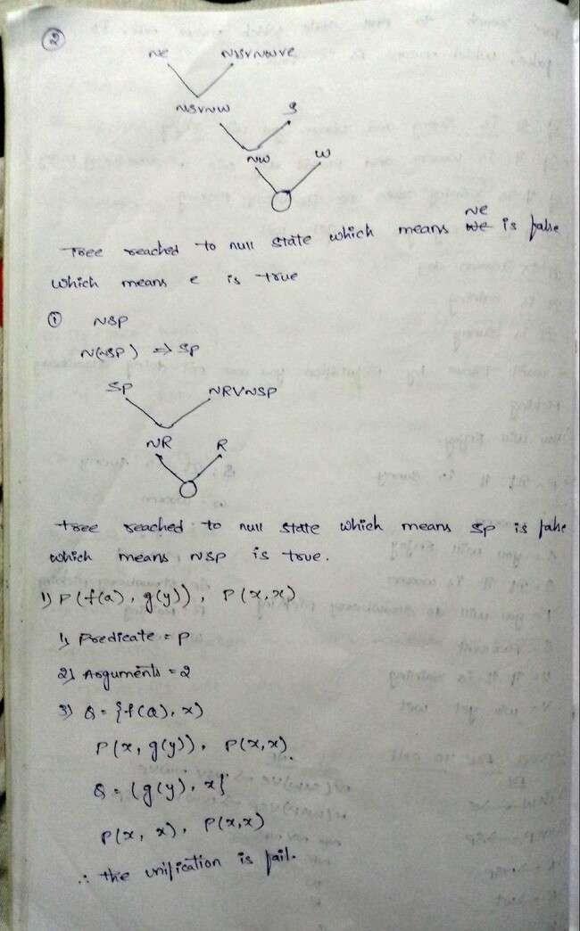

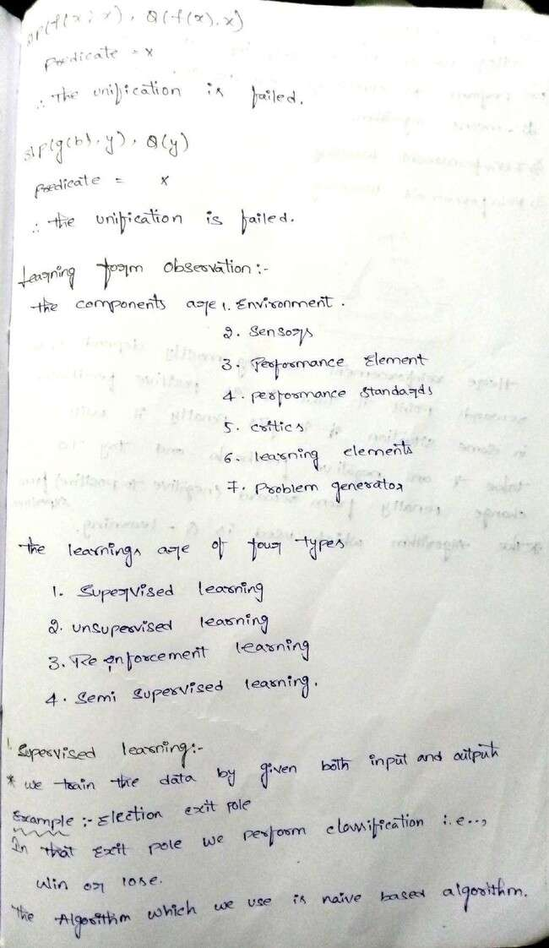

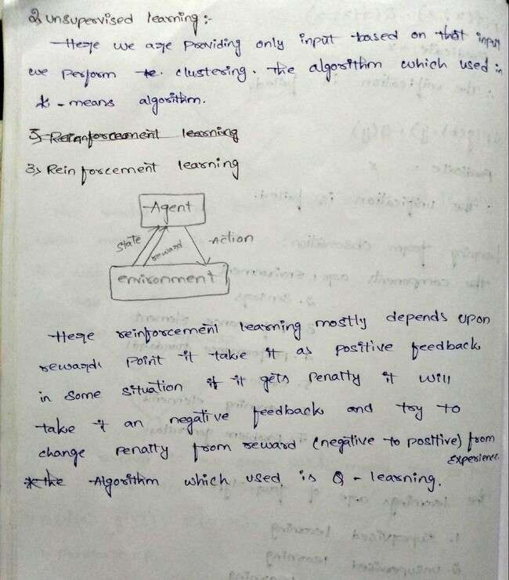

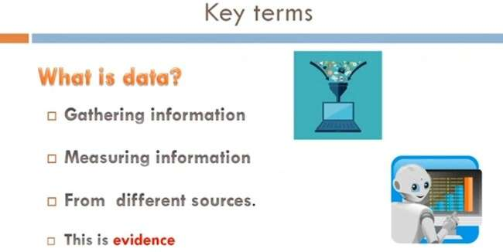

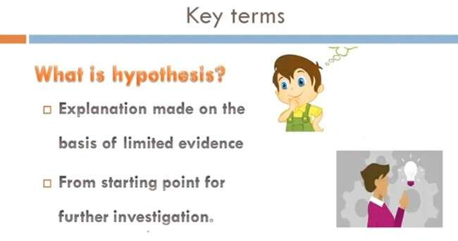

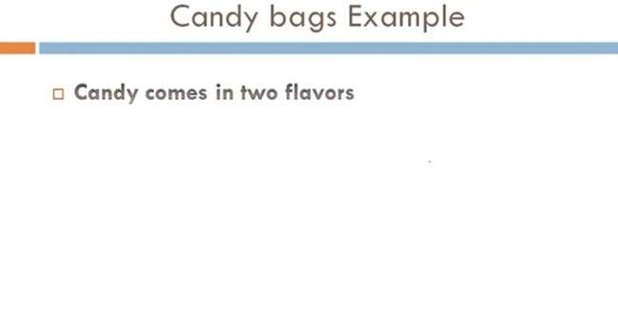

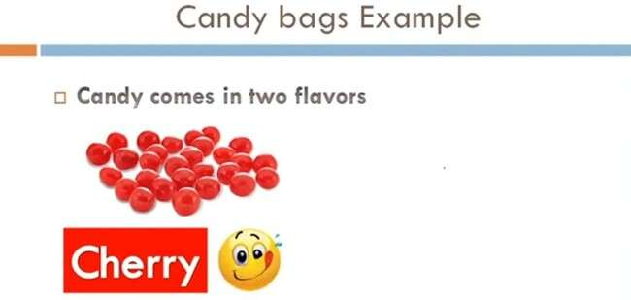

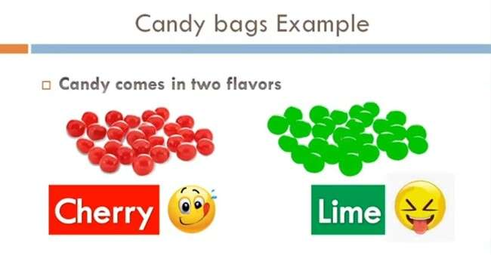

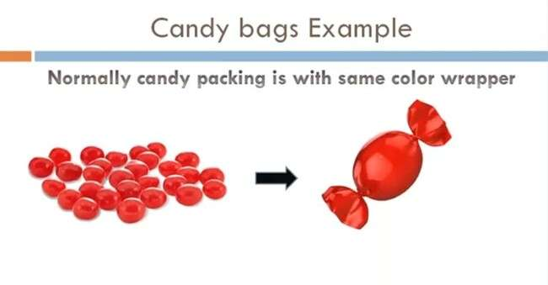

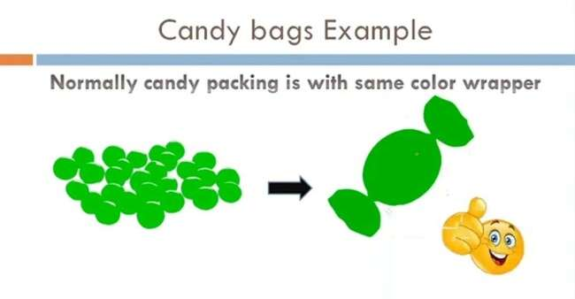

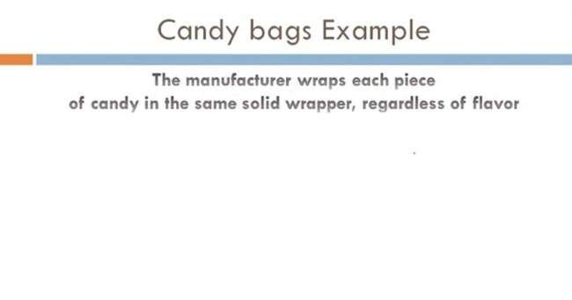

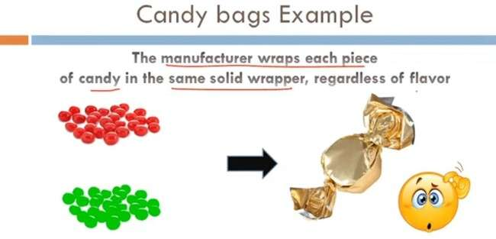

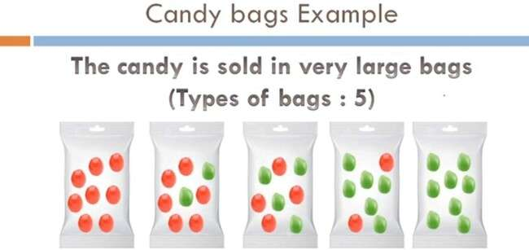

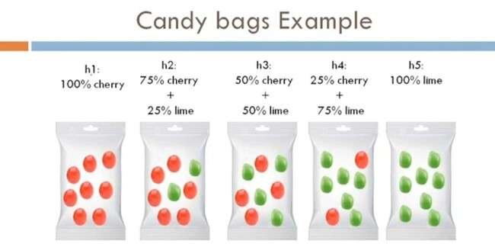

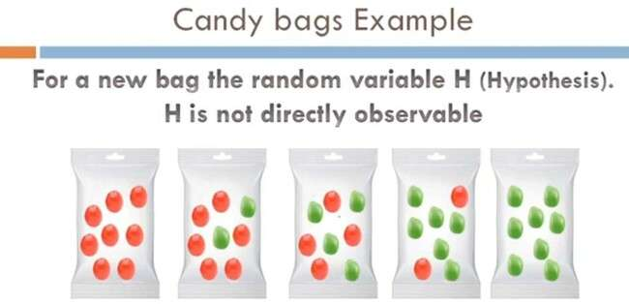



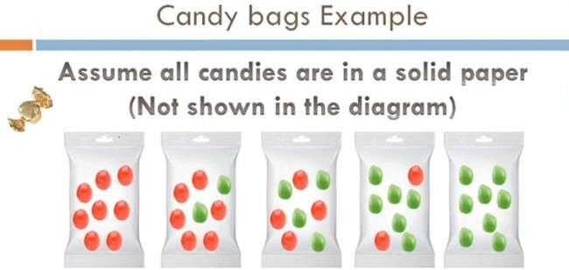

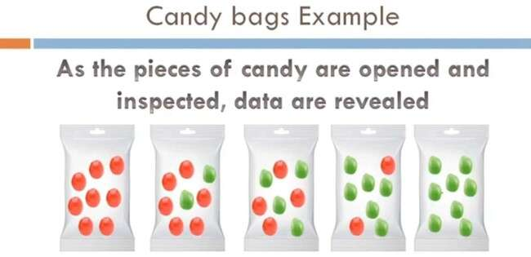

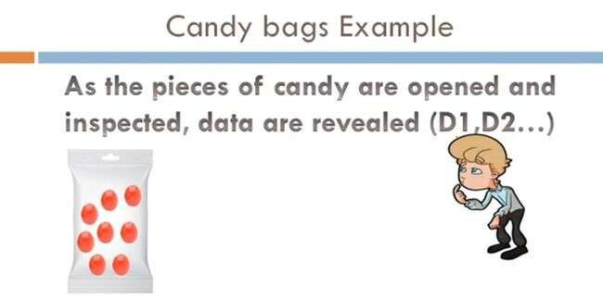

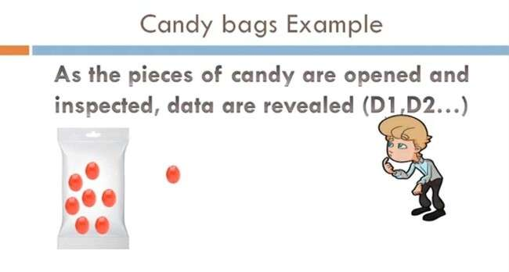

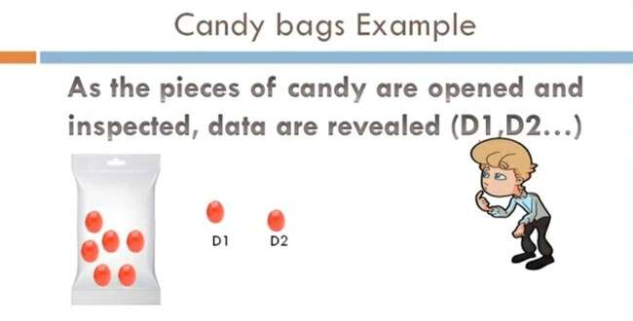

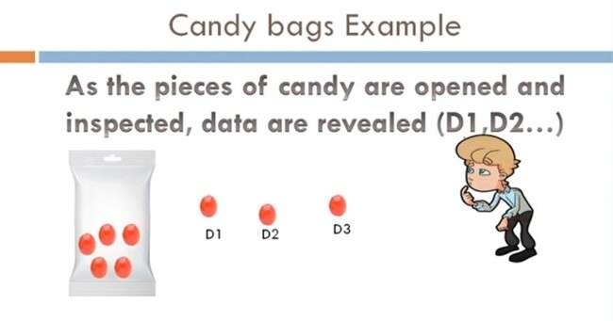

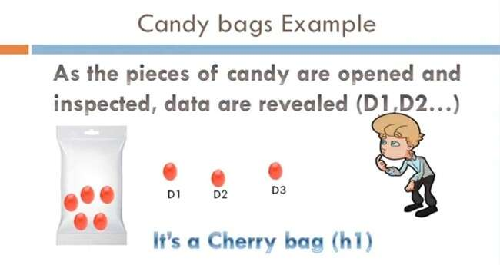

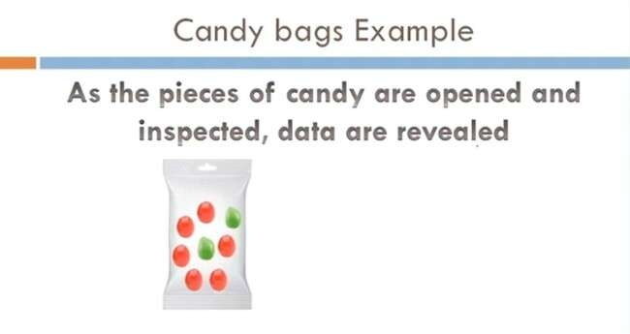

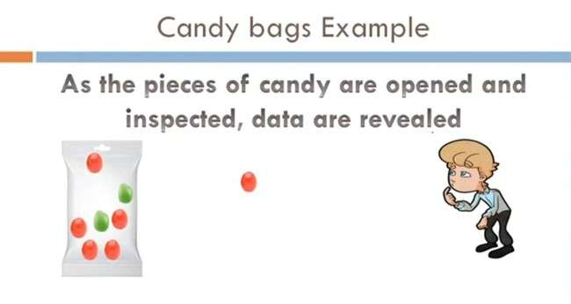

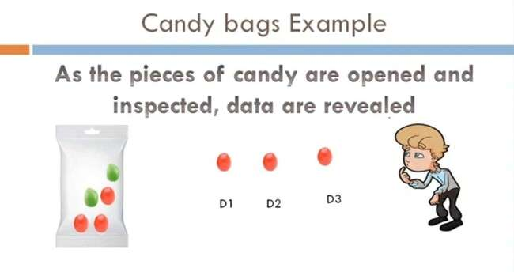

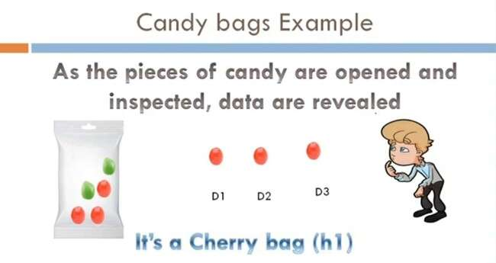

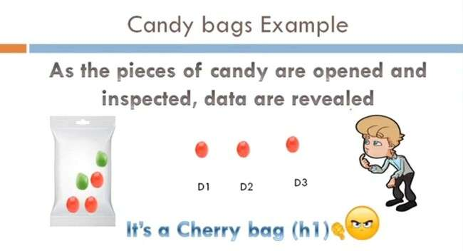

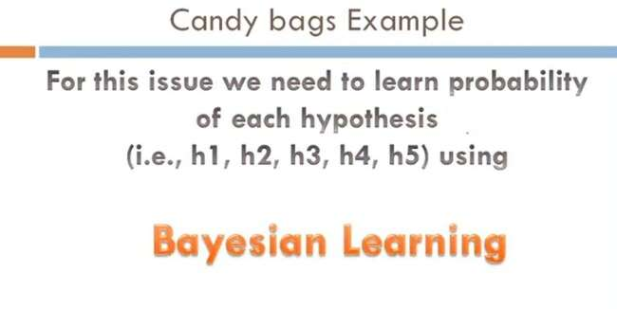

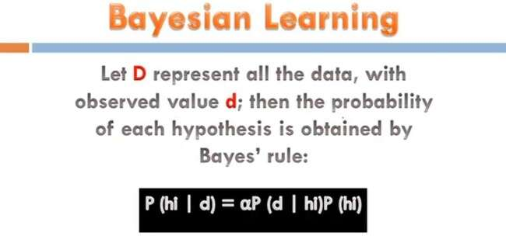

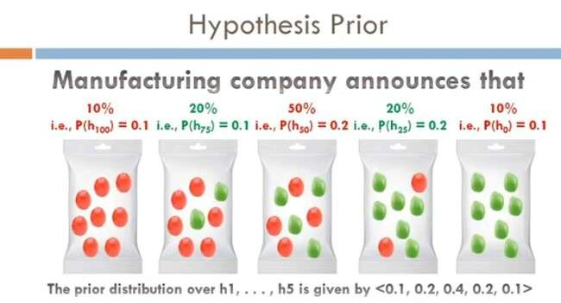

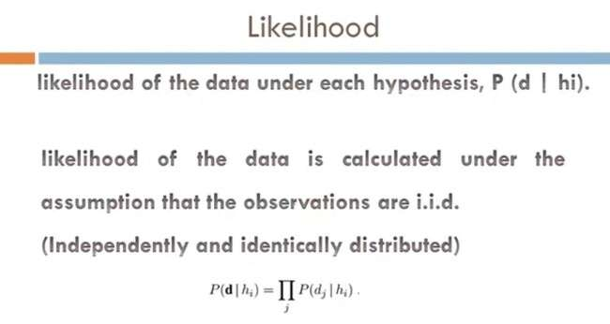

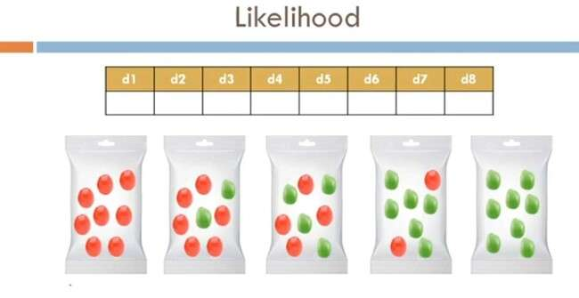

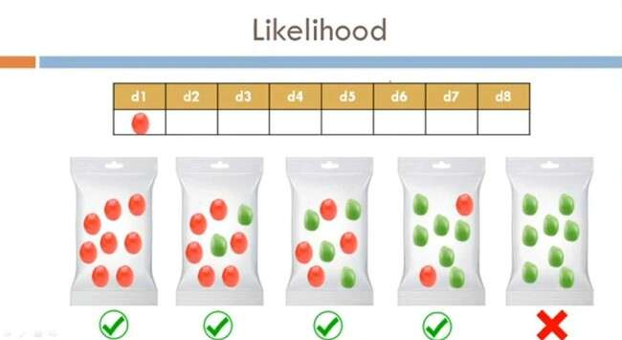

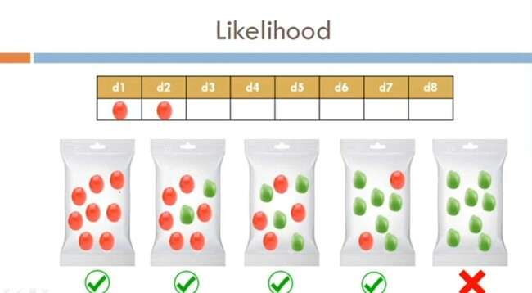

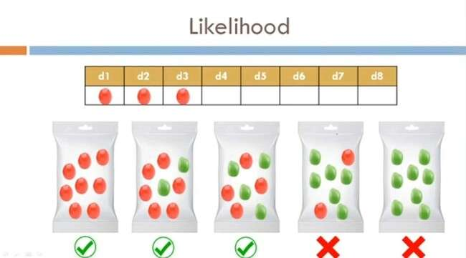

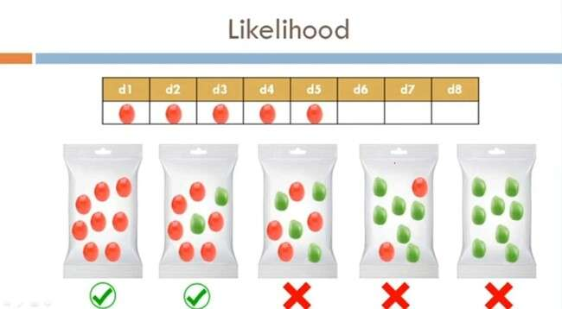

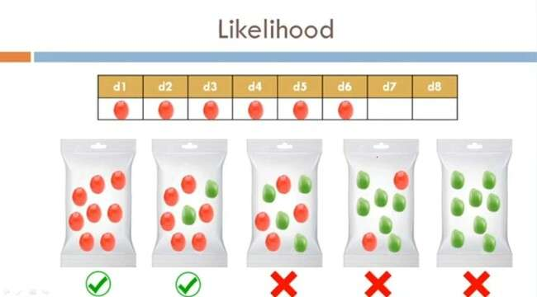

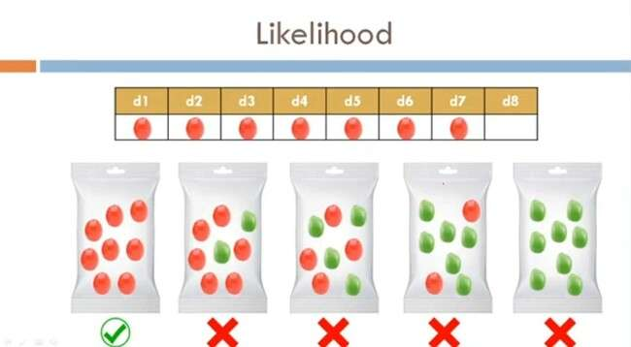

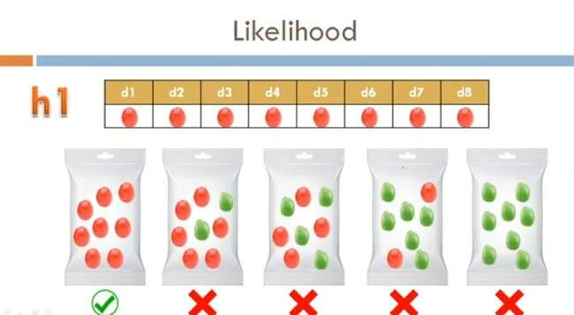

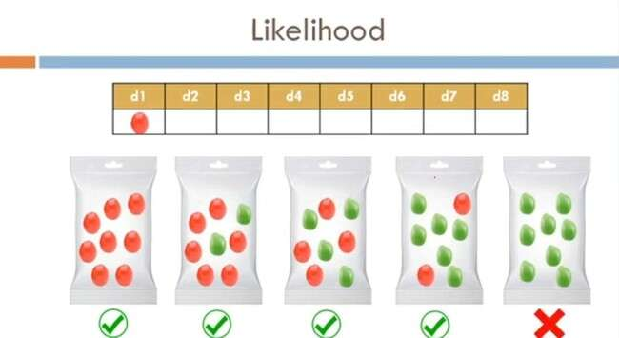

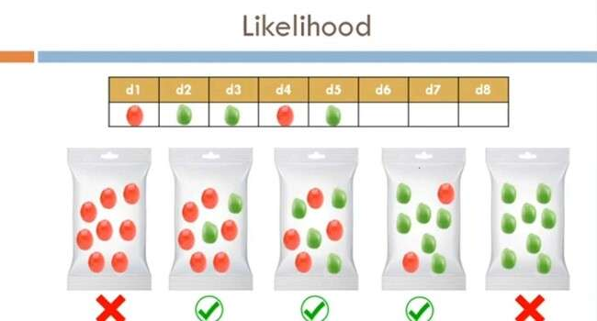

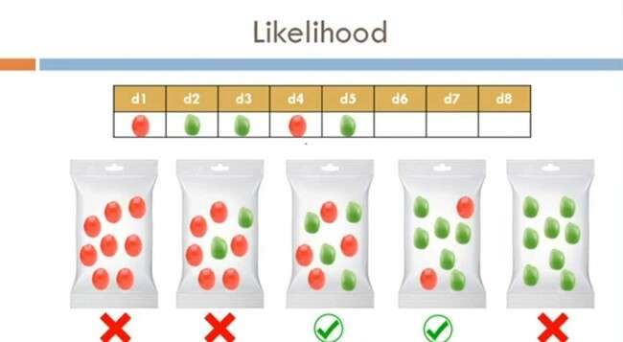

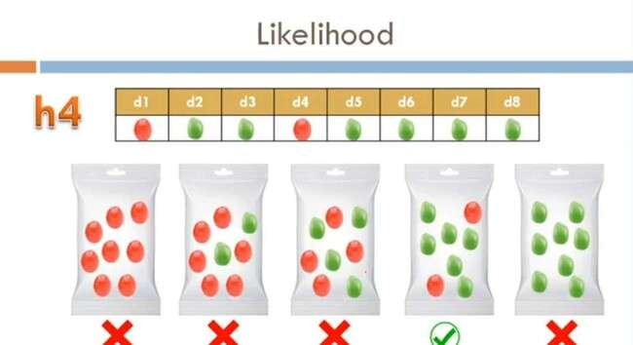

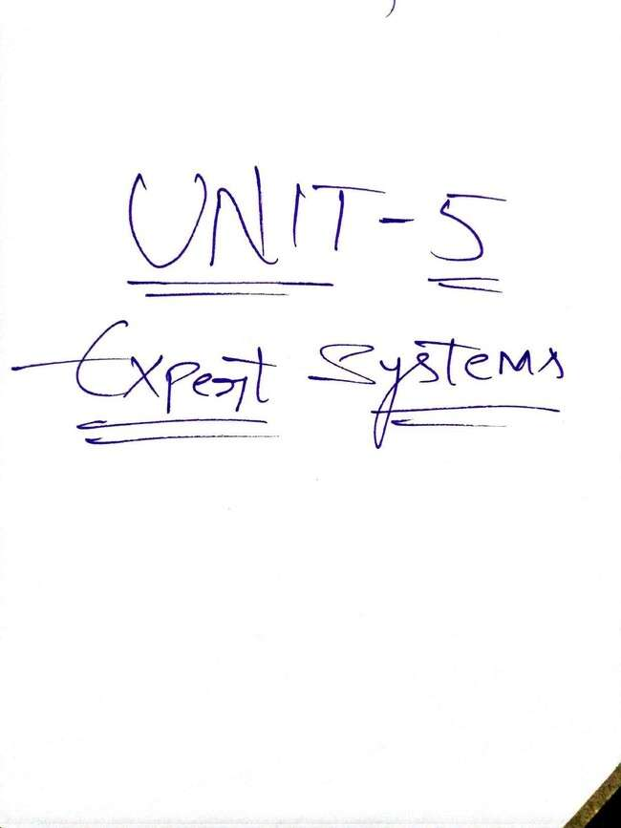

What is an Expert System?
An expert system is a computer program that is designed to solve complex problems and to provide decision-making ability like a human expert. It performs this by extracting knowledge from its knowledge base using the reasoning and inference rules according to the user queries.
The expert system is a part of AI, and the first ES was developed in the year 1970, which was the first successful approach of artificial intelligence. It solves the most complex issue as an expert by extracting the knowledge stored in its knowledge base. The system helps in decision making for compsex problems using both facts and heuristics like a human expert. It is called so because it contains the expert knowledge of a specific domain and can solve any complex problem of that particular domain. These systems are designed for a specific domain, such as medicine, science, etc.
The performance of an expert system is based on the expert's knowledge stored in its knowledge base. The more knowledge stored in the KB, the more that system improves its performance. One of the common examples of an ES is a suggestion of spelling errors while typing in the Google search box.

Below is the block diagram that represents the working of an expert system:
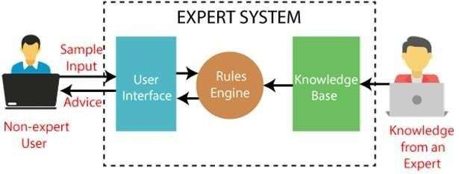

Below are some popular examples of the Expert System:
- DENDRAL: It was an artificial intelligence project that was made as a chemical analysis expert system. It was used in organic chemistry to detect unknown organic molecules with the help of their mass spectra and knowledge base of chemistry.
- MYCIN: It was one of the earliest backward chaining expert systems that was designed to find the bacteria causing infections like bacteraemia and meningitis. It was also used for the recommendation of antibiotics and the diagnosis of blood clotting diseases.
- PXDES: It is an expert system that is used to determine the type and level of lung cancer. To determine the disease, it takes a picture from the upper body, which looks like the shadow. This shadow identifies the type and degree of harm.
- CaDeT: The CaDet expert system is a diagnostic support system that can detect cancer at early stages.

Characteristics of Expert System

- High Performance: The expert system provides high performance for solving any type of complex problem of a specific domain with high efficiency and accuracy.
- Understandable: It responds in a way that can be easily understandable by the user. It can take input in human language and provides the output in the same way.
- Reliable: It is much reliable for generating an efficient and accurate output.
- Highly responsive: ES provides the result for any complex query within a very short period of time.
Components of Expert System
An expert system mainly consists of three components:
- User Interface
- Inference Engine
- Knowledge Base

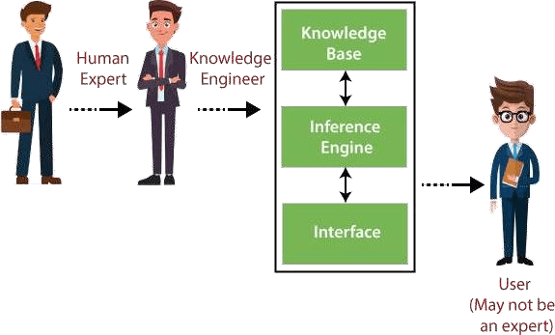

- User Interface
With the help of a user interface, the expert system interacts with the user, takes queries as an input in a readable format, and passes it to the inference engine. After getting the response from the inference engine, it displays the output to the user. In other words, it is an interface that helps a non-expert user to communicate with the expert system to find a solution.
- Inference Engine(Rules of Engine)
  - The inference engine is known as the brain of the expert system as it is the main processing unit of the system. It applies inference rules to the knowledge base to derive a conclusion or

deduce new information. It helps in deriving an error-free solution of queries asked by the user.
  - With the help of an inference engine, the system extracts the knowledge from the knowledge base.
  - There are two types of inference engine:
  - Deterministic Inference engine: The conclusions drawn from this type of inference engine are assumed to be true. It is based on facts and rules.
  - Probabilistic Inference engine: This type of inference engine contains uncertainty in conclusions, and based on the probability.
Inference engine uses the below modes to derive the solutions:
  - Forward Chaining: It starts from the known facts and rules, and applies the inference rules to add their conclusion to the known facts.
  - Backward Chaining: It is a backward reasoning method that starts from the goal and works backward to prove the known facts.
- Knowledge Base
  - The knowledgebase is a type of storage that stores knowledge acquired from the different experts of the particular domain. It is considered as big storage of knowledge. The more the knowledge base, the more precise will be the Expert System.
  - It is similar to a database that contains information and rules of a particular domain or subject.
  - One can also view the knowledge base as collections of objects and their attributes. Such as a Lion is an object and its attributes are it is a mammal, it is not a domestic animal, etc.

Components of Knowledge Base
  - Factual Knowledge: The knowledge which is based on facts and accepted by knowledge engineers comes under factual knowledge.
  - Heuristic Knowledge: This knowledge is based on practice, the ability to guess, evaluation, and experiences.
Knowledge Representation: It is used to formalize the knowledge stored in the knowledge base using the If-else rules.
Knowledge Acquisitions: It is the process of extracting, organizing, and structuring the domain knowledge, specifying the rules to acquire the knowledge from various experts, and store that knowledge into the knowledge base.

